
Final Year Project.

Why is there a divide between the Theoretical definition of Microservice Architecture when it comes to Databases and their Implementation? A serval fold problem within Distributed Databases.

Submitted By: Adam O’Mahony (T00227115)
Computing with Software Development

Date Submitted: 05/12/2024

Table of Contents
Table of Contents ii
Glossary 1
Abstract 1
Chapter 1: Introduction 2
Chapter 2: Literature Review, Databases & Microservices Architecture. 3
2.1 Replication in Database Management Systems. 3
2.1.1 Why is Database Replication Needed. 3
2.1.2 What is Database Replication? 4
2.1.3 Database Replication Methodologies 5
2.1.4 Database Replication Change Propagation Strategies. 7
2.1.5 Database Replication Termination Protocols. 9
2.2 Database Architecture 10
2.2.1 What are Database Architectures? 10
2.2.2 Centralised Architecture. 11
2.2.3 Distributed Architecture. 12
2.2.4 Cloud-based Architecture. 13
2.3 Database Models 14
2.3.1 What is a Database Model? 14
2.3.2 Relational Models. 15
2.3.3 No SQL Models. 16
2.3.4 Object-Orientated Models. 17
2.4 Distributed Database Systems. 18
2.4.1 What is a Distributed Database System? 18
2.4.2 CAP Theorem. 19
2.4.3 Database Sharding. 21
2.3.4 Challenges with Distributed Databases. 22
2.5 Microservice Architecture 23
2.5.1 Microservice Architecture - Overview. 23
2.5.2 Microservice Database Strategies. 25
2.5.3 Microservice Fault Tolerance. 27
2.5.4 Microservice Database Consistency Challenges. 28
2.5.5 Microservice Saga Pattern Implementation. 29
2.5.6 Microservice Event Driven Implementation. 31
Chapter 3: Database Technologies & Real-world Examples. 32
3.1 Database Technologies 32
3.1.1 Object Relational Mappers (ORMs). 32
3.1.2 Database Consistency – Blockchain 33
3.1.3 Database Middleware. 35
3.1.4 Change Data Capture. 36
3.1.5 Edge Databases & Datastores. 37
3.1.6 Immutable & Append Only Databases. 39
3.2 Case Studies & Example white papers. 40
3.2.1 Data Consistency issue during work placement. 40
3.2.2 Challenges with migrating Legacy software to Microservice Architecture – A review of two Papers on this topic. 42
3.2.3 White paper on challenges of microservices by JBS Software Solutions. 44
3.2.4 Databases at Scale: Challenges in a Microservices Architecture - The Spotify Data Platform. 45
3.2.5 Replication Methods Implemented in MongoDB 46
Chapter 4: Justification, Methodology & Project Scope. 48
4.1 Research Question 48
4.2 Project Proposal 49
4.3 Justification 50
4.4 Agile Development, & Jira as a Monitoring Tool. 52
4.5 Methodology, Steps to improving Data consistency in Distributed Database’s. 53
4.6 Project Specification & Scope. 54
Chapter 5: Design Documentation. 56
5.1 Jira User Stories. 56
5.2 Use Case Documents, Activity Diagrams & Sequence Diagrams. 57
5.2.1 Adding a Database. 57
5.2.2 Database Configuration. 60
5.2.3 Adding a Replication Strategy. 64
5.2.4 Adding a Consistency Strategy. 67
5.2.5 Adding a Replication Sync Checker. 70
5.3 UML Class Diagram. 74
5.4 Draft Sprints in Jira. 75
5.5 Reflection on the Design Documentation Process. 77
5.6 Testing Strategies. 78
Chapter 6: Prototype. 80
6.1 Why the Spring Framework. 80
6.2 Creating the Database Management Middleware. 81
6.3 Creating the Test for Edge Database Connection. 84
6.3 Creating the Test for Server Database Connection. 87
6.4 Findings and Results of Prototype. 89
Chapter 7: Proposed Pivot of Database Management System. 90
7.1 What can still be used based on the research, design, methodology and project plan. 90
7.2 Database Engine or Wrapper that promotes data consistency and replication using Immutable Data strategies. 91
Conclusion. 92
References & Bibliography 94
I) References: 94
II) Bibliography: 99
Table of Figures. 100
Appendixes 102
Appendix A, Jira User Stories. 102
A. I. Prototype User Stories 102
A. II. Database Management User Stories 111
A. III. Database Replication Strategies. 117
A. IV. Database Consistency Strategies. 124
A. V. Database Sync Checking. 127
A. VI. Database Merging. 131
A. VII. Database Translation 135
A. VIII. Application UI 141

Glossary
AaaS (Application-as-a-Service), ACID (Atomicity, Consistency, Isolation, Durability),
API (Application Programming Interface), BI (Business Intelligence),
CAP (Consistency, Availability, Partition Tolerance), CDC (Change Data Capture),
CQRS (Command Query Responsibility Segregation), CRUD (Create, Read, Update, Delete),
DBaaS (Database-as-a-Service), DBMS (Database Management System),
DDBMS (Distributed Database Management System), DDD (Domain-Driven Design),
GUI (Graphical User Interface), HDFS (Hadoop Distributed File System),
IaaS (Infrastructure-as-a-Service), IoT (Internet of Things),
JDBC (Java Database Connectivity), ORM (Object-Relational Mapper),
PaaS (Platform-as-a-Service), RCA (Root Cause Analysis),
REST (Representational State Transfer), SaaS (Software-as-a-Service),
SOA (Service-Oriented Architecture), SQL (Structured Query Language),
TCP (Transmission Control Protocol), TDD (Test-Driven Development).

Abstract
This research investigates the challenges of database management within microservices architectures. While microservices offer advantages like independent deployment and scalability, they introduce complexities in maintaining data consistency, managing network partitions, and ensuring overall performance.
The theoretical ideal of a dedicated database per microservice often clashes with practical implementation constraints, leading to compromises in data management strategies.
This research examines various database strategies employed in microservices, including Database per Service, Shared Database, and API Composition, highlighting their trade-offs.
The research also explores database technologies for enhancing data consistency and replication in distributed database systems.
A case study of a real-world data consistency issues encountered during a work placement illustrates the practical challenges of eventual consistency in replicated databases.
The research concludes with a proposal for a Distributed Database Management System (DDBMS) designed to address these challenges, providing a flexible platform for configuring replication strategies and consistency protocols across diverse database technologies.

Chapter 1: Introduction
Microservices architecture has emerged as a popular approach for building complex applications by decomposing them into smaller, independent services.
This modularity offers significant advantages, including independent deployment, scalability, and technology diversity. However, this distributed nature introduces inherent complexities in data management.
The traditional reliance on centralized databases clashes with the decentralized nature of microservices, requiring new strategies and technologies to manage data effectively.
One of the core challenges is maintaining data consistency across multiple services, each potentially interacting with its own database.
The theoretical ideal of a dedicated database per microservice promotes loose coupling but often faces practical implementation constraints and an overhead in administration, leading to compromises in data management and the adoption of alternative patterns like shared databases or API composition.
These alternative patterns, while offering some benefits, introduce their own trade-offs regarding data consistency, scalability, and service autonomy.
This research aims to delve into the complexities of database management within microservices architectures, exploring the practical challenges and potential solutions.
It will examine different database strategies and the role of emerging technologies like blockchain & Immutable Databases in addressing data consistency and replication challenges.
A case study of a real-world data consistency issue will highlight the practical implications of these challenges and motivate the need for more robust and flexible database management solutions for microservices.

Chapter 2: Literature Review, Databases & Microservices Architecture.

2.1 Replication in Database Management Systems.

2.1.1 Why is Database Replication Needed.
Database replication is a fundamental technique for enhancing data availability, resilience, and performance. It involves creating and maintaining copies of a database, often distributed across multiple servers or locations.
This redundancy offers protection against data loss due to hardware failures, software bugs, or accidental deletions. If the primary database becomes unavailable, applications can seamlessly switch to a replica, ensuring business continuity.
Moreover, replication can significantly improve read performance, particularly in read-heavy applications. By distributing read requests across multiple replicas, the load on the primary database is reduced, leading to faster response times and a better user experience.
This strategy also allows for geographic distribution of data, placing it closer to users and minimizing latency. Finally, replication supports disaster recovery scenarios by providing offsite copies of the data, enabling rapid restoration in case of catastrophic events.
Database replication doesn't directly improve write performance in terms of reducing overall system load. Every write operation still needs to be processed by all nodes to maintain data consistency.
However, if eventual consistency is acceptable for the application and a Master-Master replication strategy is employed, the timing of write operations can be strategically managed. By spreading write operations over time, peaks in write traffic can be mitigated, potentially improving overall system responsiveness.
The primary advantage of replication for writes remains the increased availability provided by having multiple nodes capable of accepting write and read requests.
There is a consensus within industry that a minimum of three nodes of a database should be maintained, generally expressed as a master node and two replicas. However, should the required load of the database exceed this configuration an approach of N+1 should be adopted with N being the number of nodes required to maintain the system.

2.1.2 What is Database Replication?
Database Replication is the frequent transferral of data stored in one database into another database, in a distributed system this secondary (or nth tier) database is also available to be used in conjunction with the original, this is what is known as a “Master-Slave” orientation in a distributed system, where one database consistently updates the other database replicas.
A primary distinction between “Master-Slave” and “Master-Master” replication architectures lies in write operations.
In a Master-Slave setup, writes are exclusively directed to the Master node, while reads can be distributed across all nodes. This simplifies data consistency management but creates a potential bottleneck at the Master.
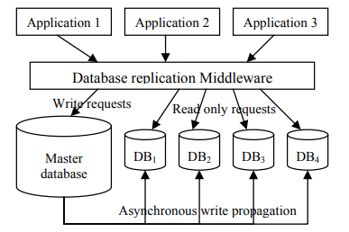
Figure 1- Example of Master Slave replication middleware (Cecchet, Candea and Ailamaki, 2008)
Conversely, Master-Master replication allows writes on any node, enhancing availability and write throughput. However, this introduces the complexity of resolving data conflicts arising from concurrent writes to different Master nodes targeting the same data.(Cecchet, Candea and Ailamaki, 2008).
This trade-off between consistency and availability is a key consideration in choosing the appropriate replication strategy.
In distributed systems where multiple databases are available based on geographic or availability constraints the relation between each database is commonly referred to as a federation, where in data is readily available and data flows between each database based on the system architecture and settings.
Another form of database replication occurs in what is known as Database Merging, this is the formation of a larger centralised database from multiple smaller databases.
This can occur in microservices where each service has its own database which feed into a data warehouse or larger database in order for analytical or business processing.

2.1.3 Database Replication Methodologies
There are two main replication methodologies for transferring of data between databases one is Lazy Replication where data is transferred from one database to another by asynchronously replicating changes. This means that changes made to the source database are not immediately replicated to the target database. Instead, the changes are queued up and replicated at a later time, often based on a schedule or trigger.
“One of the challenges in database replication is to introduce replication without severely affecting performance. Because of this difficulty, current database products use lazy replication, which is very efficient but can compromise consistency.”(M. Wiesmann et al., 2000)
The other is Eager Replication which is the replication methodology where changes made to the source database are immediately replicated (synchronously) across the database federation from the source database to the target database, therefore ensuring that data on both databases is consistent and enforcing the concept of serialisation of data.

However, this can introduce latency and also has an increased load on the system as tables will be locked for the duration of this update.
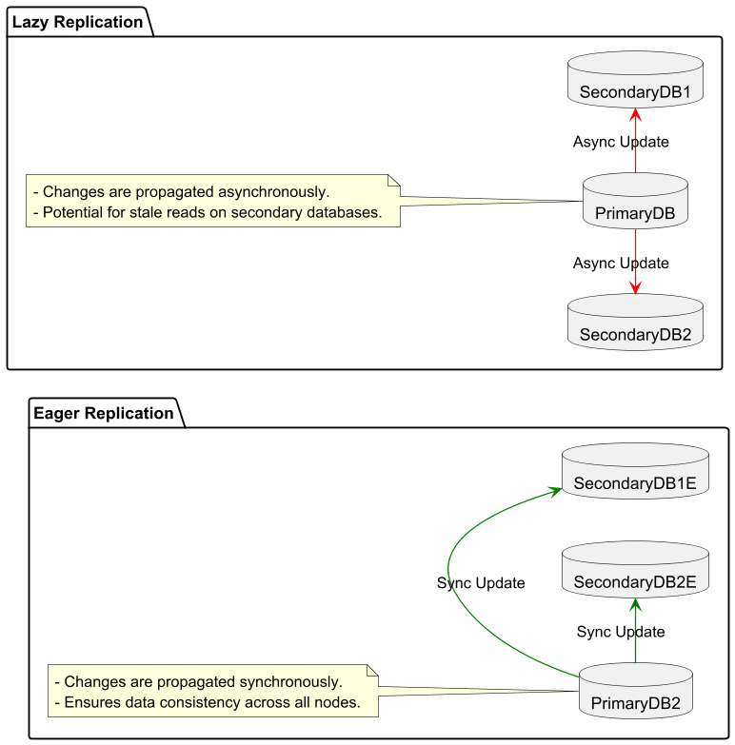
Figure 2 - Lazy vs Eager Replication
There are several parameters to consider when choosing which database replication strategy is effective in a given use case. The main parameters to consider are the replication Server Architecture, how data changes are propagated throughout the database, and what termination protocol is used. This is the three-parameter classification described and investigated by Wiesmann and his team.(M. Wiesmann et al., 2000)

In the case of low connectivity environments, an asynchronous approach such as Lazy Replication may be considered the most suitable as it allows for the scheduling of updates and therefore, if an update fails, it can be rescheduled for the next appropriate time frame.
However, due to the nature of Lazy Replication techniques, the consistency of data may be compromised as they do not enforce one-copy serialisation. As such, conflicts may occur where the same data has been updated by two separate databases at similar time frames.
Therefore, a hybrid approach where the replication of a database is lazy in nature but holds the transactional or one-copy serialisation characteristics of Synchronous Replication may be beneficial in such scenarios.

2.1.4 Database Replication Change Propagation Strategies.
Change propagation strategies in database replication determine how updates are disseminated from the primary database to its replicas, impacting consistency, performance, and fault tolerance. Beyond the fundamental choice between eager and lazy replication, several strategies exist, each with its own trade-offs.
One common strategy is full-table replication, where the entire table is copied to each replica. While simple to implement, this approach can be inefficient for large tables with frequent updates, consuming significant bandwidth and storage.
Another strategy is row-based replication, where only changed rows are propagated. This approach reduces the amount of data transferred, improving efficiency, especially for large tables with sparse updates. However, it requires mechanisms to track and identify changed rows, potentially adding complexity.
Statement-based replication propagates the SQL statements that caused the changes. This can be efficient for simple updates but can lead to inconsistencies if statements have non-deterministic behaviour or rely on server-side functions.
More sophisticated strategies include logical replication, which captures changes at a logical level, often using a transaction log. This approach offers greater flexibility and consistency compared to statement-based replication but can be more complex to implement.
Trigger-based replication uses database triggers to capture changes and propagate them to replicas. This allows for fine-grained control over replication but can impact performance if not carefully designed.
“Triggers, for example, are often used to perform reporting tasks and may update a different reporting database instance.”(Cecchet, Candea and Ailamaki, 2008)
Other systems such as Hadoop's Distributed File System (HDFS) employs block-level replication for data redundancy and fault tolerance. Files are divided into fixed-size blocks, typically 128MB or 256MB, and each block is replicated independently across multiple Data Nodes. This approach allows for parallel replication, enhancing performance and enabling efficient recovery from Data Node failures.(Veeramalla, 2023)
By replicating at the block level, HDFS ensures data availability even if individual nodes fail, contributing to the system's overall robustness.
The image below shows an overview of the strategies and where it may be appropriate to use them.
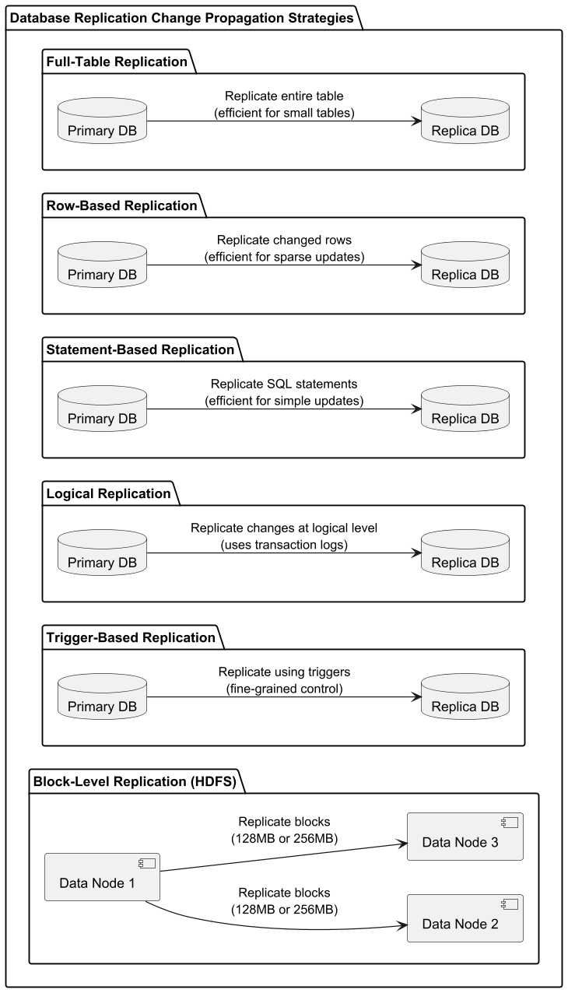
Figure 3 - Replication Strategies Summarized.

2.1.5 Database Replication Termination Protocols.
Database replication termination protocols determine how a system decides to accept or reject a data transfer, concluding the replication process for a given update. These protocols generally fall into two categories: voting and non-voting.
Voting protocols, like quorum-based consensus, require a majority of replicas to acknowledge successful application of the changes before the primary considers the transaction replicated.
This approach offers fault tolerance and reasonable consistency but can introduce latency. Paxos and Raft are examples of more sophisticated voting protocols that provide stronger consistency guarantees, even in the presence of network partitions or failures.
“Fast Paxos observes that it is possible to improve on the previous latency (in terms of common case message steps) by allowing proposers to propose values directly to acceptors [12]. To this end, the protocol distinguishes between fast and classic ballots, where fast ballots bypass the leader by sending proposals directly to acceptors and classic ballots work as in Basic Paxos”(Pires, Ravi and Rodrigues, 2018)
Non-voting protocols, such as acknowledgment-based termination, typically rely on simpler mechanisms. The primary database awaits acknowledgments from all or a designated subset of replicas before considering the transaction replicated.
This can ensure strong consistency but may be less fault-tolerant and potentially introduce performance bottlenecks if a replica is slow or unavailable.
One-phase commit and two-phase commit are examples of non-voting protocols that offer different levels of consistency and performance trade-offs.
The choice between voting and non-voting protocols depends on factors like consistency requirements, performance goals, and the complexity of the replication environment.
A well-chosen termination protocol is crucial for maintaining data integrity and reliability in a replicated database system.

2.2 Database Architecture

2.2.1 What are Database Architectures?
Database architectures describe the structure and organization of a database system, encompassing how data is stored, accessed, and managed. There are three main types of database architectures which are Centralised, Distributed and Cloud-based.
While centralized and distributed systems can be deployed on cloud infrastructure, cloud-based architectures typically refer to Database-as-a-Service (DBaaS) deployments, which offer managed database services on cloud platforms.
Choosing the right architecture is crucial for optimizing performance, scalability, and cost-effectiveness, and depends heavily on the specific application requirements and data characteristics.
Understanding the trade-offs between each architecture is essential for making informed design decisions as such these main architectures will be looked at independently to gain a better understanding of their characteristics and drawbacks.
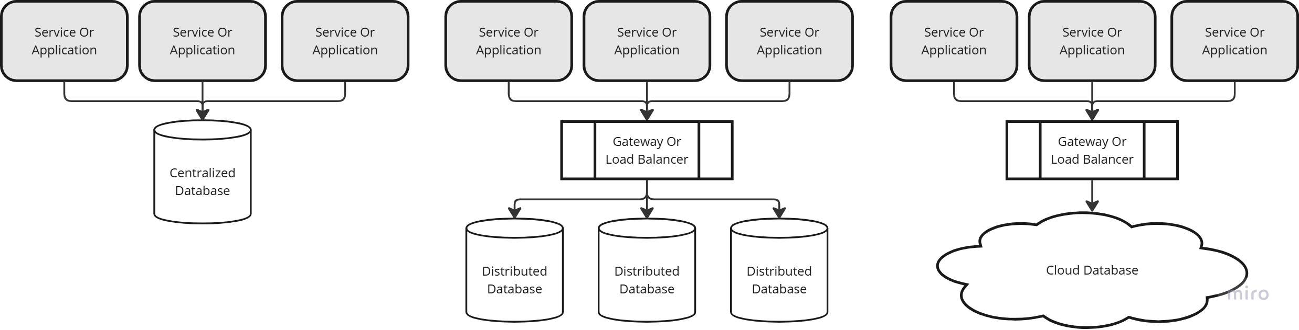
Figure 4 - Database Architecture Simplified

2.2.2 Centralised Architecture.
In a centralized database architecture, all data resides on a single server. This consolidated approach simplifies management and administration tasks, as all database operations and maintenance are focused on one machine.
However, this simplicity comes at the cost of limited scalability. As data volumes and user requests increase, the single server can become overwhelmed, creating performance bottlenecks and impacting application responsiveness.
This reliance on a single server introduces a significant single point of failure. If the server experiences hardware or software issues, the entire database becomes unavailable, potentially disrupting critical business operations.
Therefore, centralized architectures are generally best suited for smaller applications with moderate data volumes and where high availability and fault tolerance are not primary requirements.
For applications requiring greater scalability, reliability, and performance, distributed or cloud-based architectures are often more appropriate.

2.2.3 Distributed Architecture.
Distributed database architecture enhances scalability, reliability, and performance by spreading data across interconnected servers. This distribution allows for handling larger datasets and higher query loads, while data redundancy improves fault tolerance.
“A distributed database is also a set of databases stored on multiple computers that typically appears to applications as a single database.”(Zubi, 2009)
However, distributed systems introduce complexities in maintaining data consistency and managing transactions, with network latency becoming a performance factor.
Different types of distributed architectures exist, including homogeneous systems (using the same DBMS on all servers) and heterogeneous systems (allowing different DBMSs). The choice depends on factors like data volume, consistency requirements, and the need for interoperability with existing systems.
Data partitioning schemes, such as sharding or horizontal partitioning, are employed to distribute data effectively across the servers.
Therefore, consensus protocols and locking mechanisms are crucial for ensuring data consistency and managing concurrent transactions within a distributed environment.

2.2.4 Cloud-based Architecture.
Cloud-based database architectures leverage cloud platforms to host and manage database services. This approach offers several advantages, including scalability, elasticity, and reduced administrative overhead.
Cloud providers handle infrastructure management, allowing users to focus on application development and data management. Scalability is achieved through on-demand resource provisioning, enabling databases to adapt to fluctuating workloads which may come at an increased cost.
Furthermore, cloud databases offer various service models, including Infrastructure as a Service (IaaS), Platform as a Service (PaaS), and Software as a Service (SaaS), catering to different levels of control and management requirements.
“Application-as-a-Service (AaaS) or SaaS is defined as a software model in which both the application and the relevant data is hosted on a cloud by independent developers, which enables a user to access the software as and when required from any location.”(Chopra, 2017)
However, factors like vendor lock-in, security concerns, and data governance need careful consideration when adopting a cloud-based architecture.
The choice of specific cloud services and deployment models depends on factors such as application needs, budget constraints, and compliance requirements.

2.3 Database Models

2.3.1 What is a Database Model?
A database model provides the blueprint for how data is structured and organized within a database system. It defines the logical framework for representing real-world entities, their attributes, and the relationships between them.
This blueprint dictates how data is stored, accessed, and manipulated, serving as the foundation for all database operations. Choosing an appropriate database model depends heavily on the specific application requirements, including the type of data being stored, the relationships between data elements, and the expected query patterns. A well-chosen model ensures data integrity, efficiency in data retrieval, and scalability for future growth.
The relational model, for example, structures data into tables with rows and columns, utilizing keys to establish relationships between these tables.
Object-oriented models, on the other hand, represent data as objects with properties and methods, mirroring the principles of object-oriented programming.
NoSQL models encompass a diverse range of approaches, offering flexibility for handling large volumes of unstructured or semi-structured data.
The selection of a database model has implications for the overall performance and functionality of a database system.
It influences the types of queries that can be efficiently executed, the ease of maintaining data integrity, and the scalability of the system to accommodate growing data volumes.
Subsequent sections will delve into the specifics of various models, providing a deeper understanding of their respective features and applications.
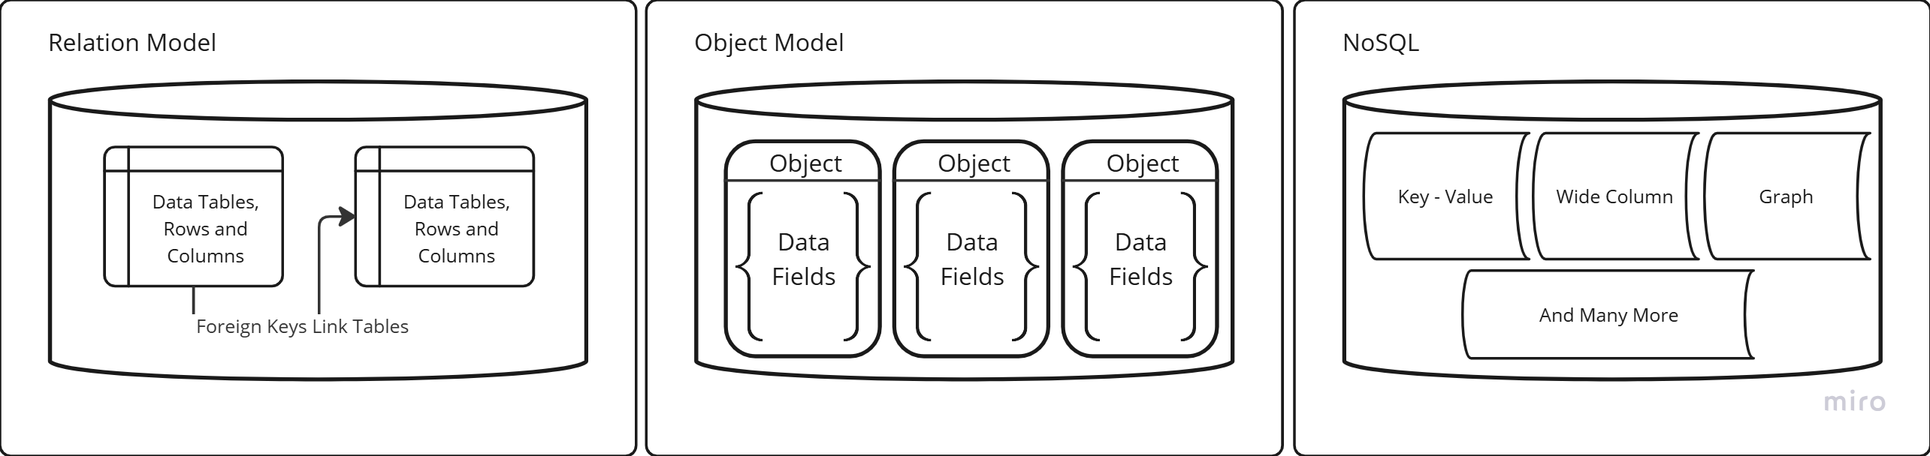
Figure 5 - Data Models, Simplified example

2.3.2 Relational Models.
The relational model, foundational to contemporary database management, structures data within interconnected tables. These tables comprise rows, formally termed tuples, representing individual records, and columns, or attributes, denoting specific data fields.
“In the relational model, relations are used to hold information about the objects to be represented in the database. A relation is represented as a two-dimensional table in which the rows of the table correspond to individual records and the table columns correspond to attributes .”(Connolly and Begg, 2014)

Each table embodies a relation, a structured association between distinct data elements. Illustratively, a “Customers” table might include attributes such as CustomerID, Name, Address, and Phone Number, with each tuple representing a unique customer entity.
Inter-table relationships are established through foreign keys, attributes referencing primary keys in related tables, thereby linking associated data across the database schema. This structure enables the representation of complex relationships between entities in a structured and organized manner.
Central to the relational model's efficacy are its mechanisms for ensuring data integrity. Constraints, such as primary keys, which uniquely identify each tuple within a table, and foreign keys, which enforce referential integrity between tables, contribute to data consistency and accuracy.
Furthermore, the relational model leverages Structured Query Language (SQL) as its primary interface for data manipulation and retrieval. SQL provides a standardized and expressive language for querying, inserting, updating, and deleting data, as well as for managing the database schema itself. The combination of structured data organization and robust integrity constraints facilitates reliable data management and retrieval.
The relational model's prevalence in diverse applications, from transactional systems to analytical platforms, stems from its inherent strengths. Its structured nature lends itself to efficient data analysis and reporting, while the enforced data integrity ensures the reliability and trustworthiness of the stored information.
The widespread adoption of SQL as the standard language for relational database interaction further enhances its portability and interoperability across various platforms.
Consequently, the relational model remains a dominant paradigm in database systems, providing a robust and scalable foundation for managing structured data.

2.3.3 No SQL Models.
NoSQL databases, encompassing a diverse array of data management approaches, depart from the rigid schema and relational structure of traditional relational databases.
Designed to address the challenges posed by large volumes of unstructured or semi-structured data, NoSQL systems offer flexible schemas, distributed architectures, and specialised data models optimized for specific data types and access patterns.
These models include document stores, key-value stores, graph databases, and column-family stores, each catering to distinct use cases and performance requirements. This diversity allows for greater flexibility in data representation and manipulation compared to the rigid structure of relational models.
The schema flexibility inherent in NoSQL databases facilitates the handling of evolving data structures and diverse data formats. Document stores, for instance, store data in self-describing documents, typically in JSON or XML format, eliminating the need for predefined schemas.
Key-value stores provide a simple yet highly scalable mechanism for storing and retrieving data based on unique keys. Graph databases excel at representing relationships between entities, making them ideal for social networks, knowledge graphs, and recommendation systems.
Column-family stores offer high performance for read-heavy workloads by storing data in column-oriented tables, enabling efficient retrieval of specific data attributes. The choice of a specific NoSQL model depends heavily on the nature of the data and the intended application.
The distributed nature of many NoSQL systems enables horizontal scalability, allowing them to handle massive datasets and high traffic loads by distributing data across multiple servers. This scalability, combined with the schema flexibility and specialised data models, makes NoSQL databases well-suited for applications such as web analytics, e-commerce, social media, and Internet of Things (IoT) data management.
“The NoSQL database approach is characterized by flexibility in storage and manipulation of data, improvements in performance and allowing for easier scalability.”(Mapanga and Kadebu, 2013)
While NoSQL databases offer advantages like scalability and flexibility by adhering to BASE (Basically Available, Soft state, Eventually consistent) properties, prioritizing availability and partition tolerance over strict consistency.
This approach contrasts with the ACID (Atomicity, Consistency, Isolation, Durability) properties of relational databases, which guarantee strong consistency but may sacrifice availability, especially in distributed systems, requiring careful consideration of data consistency and integrity trade-offs.
Therefore, the selection of a NoSQL database necessitates a thorough evaluation of the specific application needs and the trade-offs inherent in each model.

2.3.4 Object-Orientated Models.
Object-oriented models in databases represent data as objects, mirroring the principles of object-oriented programming. These objects encapsulate both data (attributes), behaviour (methods), and Inheritance, which allows objects to inherit properties and methods from parent objects, allowing for a more natural representation of complex real-world entities.
For example, a “Customer” object might have attributes like name and address, along with methods like “calculateLoyaltyDiscount” or “updateContactInformation.” This encapsulation promotes code reusability and modularity, simplifying database development and maintenance.
Object-oriented models are particularly well-suited for applications dealing with complex data structures, such as multimedia data, spatial data, and design documents. Their ability to store and manipulate complex objects directly within the database eliminates the impedance mismatch often encountered when mapping object-oriented application code to relational databases.
“A major benefit of this approach is the unification of the application and database development into a seamless data model and language environment. As a result, applications require less code, use more natural data modeling, and code bases are easier to maintain.”(Vidhya, Jeyaram and Ishwarya, 2016)
This seamless integration simplifies development and improves performance by avoiding complex object-relational mapping (ORM) layers. Furthermore, these models often support features like versioning and complex data types, making them suitable for applications requiring intricate data management capabilities.
While object-oriented models offer advantages for specific domains, they have not achieved the widespread adoption of relational databases. Factors contributing to this include the steeper learning curve associated with object-oriented concepts, the historical dominance of relational databases, and the performance overhead associated with some object-oriented features.
However, they remain a viable option for applications requiring the flexibility and expressiveness of object-oriented programming within the database itself, particularly in niche areas like computer-aided design (CAD), geographic information systems (GIS), and scientific data management.

2.4 Distributed Database Systems.

2.4.1 What is a Distributed Database System?
A Distributed Database System (DDBS) is a collection of logically interrelated databases spread physically across various sites in a computer network.
Unlike a centralized database residing on a single machine, a DDBS manages data across multiple locations, connected by a communication network.
This distribution allows for localized access to portions of the database while maintaining a globally consistent view of the entire data collection. The end user perceives the distributed database as a single logical entity, masking the underlying complexity of data distribution and management.
A distributed database system can leverage replicated databases to enhance availability and performance. By distributing data across multiple replicas, the system ensures continued operation even if some replicas fail.
This replication strategy also improves read/write speeds by reducing contention on individual database instances, essentially spreading the workload across multiple copies of the data. This approach enhances both fault tolerance and overall throughput.
While a distributed database can leverage replication for availability, it doesn't always mean identical copies. Data can also be strategically divided, based on business domains like sales and deliveries, which is commonly referred to as Fragmentation.
This approach allows for more efficient data management by localizing specific data subsets to relevant departments or locations.
Managing the distributed database system has become a real issue for many companies, the project proposed later in this paper is one such solution for managing the replication strategies and distribution of information within a distributed database system.
“Distributed DBMSs should help resolve the islands of information problem. Databases are sometimes regarded as electronic islands that are distinct and generally inaccessible places, like remote islands.”(Connolly and Begg, 2014)

2.4.2 CAP Theorem.
Brewer's CAP theorem proposes that distributed databases cannot simultaneously guarantee consistency, availability, and partition tolerance.
Consistency means all data is identical across all nodes at the same time. Availability ensures every request gets a response, even with some node failures. Partition tolerance means the system continues functioning despite network interruptions that isolate some nodes. A distributed system can only guarantee two of these three properties simultaneously.(Zhao, 2014)
“In terms of CAP Theorem, if we partition the data, we may lose the availability since we find the error and then shut down the system until the error is resolved. The natural question is how to make a trade-off between availability and partition tolerance.”(Kong et al., 2015)
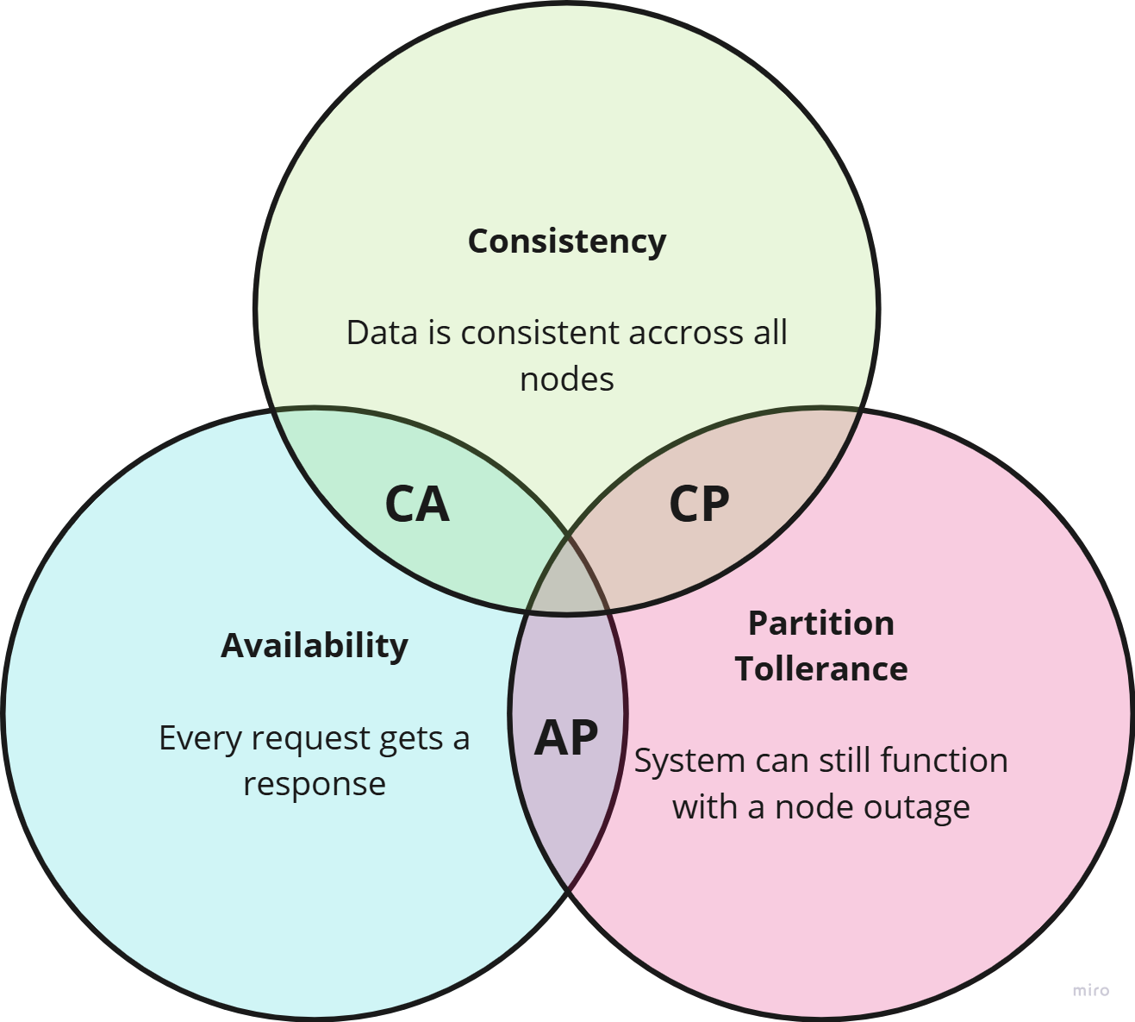
Figure 6 - Simplified CAP Theorem Venn Diagram
In practice, partition tolerance is a necessity in most distributed systems, as network failures are inevitable. Therefore, the choice typically lies between consistency and availability.
Systems that prioritize consistency, like many traditional relational databases, ensure that all data remains consistent across all nodes, even during network partitions. However, this may result in reduced availability if some nodes become unreachable.
Conversely, systems that prioritize availability, like many NoSQL databases, guarantee that every request receives a response, even if it means temporarily sacrificing data consistency during partitions.
This leads to the concept of eventual consistency, where data eventually becomes consistent across all nodes after the network partition is resolved.
The specific choice between consistency and availability depends on the specific application requirements and the trade-offs between data consistency and system uptime.

2.4.3 Database Sharding.
Database sharding is a horizontal partitioning technique used to distribute large datasets across a cluster of database servers, enhancing scalability and performance. Unlike replication, which copies the entire dataset across multiple servers, sharding divides the data into smaller, self-contained units called shards, each residing on a separate server.
This architecture allows for horizontal scaling by simply adding more servers to the cluster as data volume grows, avoiding the scaling limitations of a single, large database server. A shard key, often a column or a combination of columns, determines the distribution of data across shards, acting as a mapping function between data items and specific shards. For instance, a customer's ID could serve as a shard key, distributing customers across different shards based on ID ranges or a hashing function.
Effective sharding requires careful consideration of the shard key selection. A well-chosen shard key distributes data evenly across shards, minimizing data skew and maximizing query performance. Common sharding strategies include range sharding, where data is partitioned based on ranges of the shard key, hash sharding, which uses a hash function to distribute data more randomly, and list sharding, which assigns specific key values to specific shards.
The choice of sharding strategy depends on the data distribution and query patterns of the application. Furthermore, sharding introduces complexities in data management, such as cross-shard joins and data rebalancing when adding or removing shards, requiring specialised tooling and strategies.
“The time considered to search all the data nodes is high, which will affect the throughput and performance of distributed search engines. So to overcome this limitation sharding technique is implemented in distributed processing system using sharding technique.”(Dhulavvagol, Totad and Bhandage, 2022)
Sharding offers significant benefits for applications dealing with massive datasets and high throughput requirements. By distributing data and query load across multiple servers, sharding improves query performance, increases system capacity, and enhances fault tolerance. If one shard becomes unavailable, the rest of the system can continue operating, ensuring high availability.
However, the added complexity of managing a sharded database environment necessitates careful planning and implementation to fully realize its potential benefits.

2.3.4 Challenges with Distributed Databases.
Distributed databases, while offering scalability and fault tolerance, introduce complexities in maintaining data consistency, managing network partitions, and ensuring performance.
The CAP theorem highlights the inherent trade-offs between consistency, availability, and partition tolerance in distributed systems. Network partitions can lead to data inconsistencies, requiring careful consideration of consistency models like eventual consistency.
Furthermore, distributing data across multiple nodes introduces latency and necessitates sophisticated mechanisms for data synchronisation and transaction management. These challenges are amplified in microservices architectures, where each service may interact with its own database, complicating data management and consistency.
The fact that microservices have become a hot topic in recent years has led to many systems being over-engineered resulting in systems that while functional may be bloated for the specific use case.
Data replication and sharding, while essential for scalability and high availability, introduce their own set of challenges.
Replication requires careful management of data synchronisation and conflict resolution across replicas.
Sharding, while enabling horizontal scaling, introduces complexities in query routing, cross-shard joins, and data rebalancing. Maintaining data consistency across shards in the presence of network partitions is particularly challenging.
Cloud computing environments, while offering scalable infrastructure, introduce additional considerations for distributed databases. Data security and privacy become paramount when storing sensitive data in a shared cloud.
“Many of the information resources that are made available and maintained in distributed systems have a high intrinsic value to their users. Their security is therefore of considerable importance.”(Coulouris et al., 2011)
Managing network latency and bandwidth limitations across geographically distributed data centres requires optimization.
Integrating with cloud-specific services and APIs can also introduce complexities. Successfully leveraging cloud computing requires a thorough understanding of the cloud environment and best practices for security, performance, and reliability.

2.5 Microservice Architecture

2.5.1 Microservice Architecture - Overview.
The microservices architecture builds applications as a suite of small, independent, and loosely coupled services. Each service concentrates on a single business function and interacts with others using lightweight network protocols.
Unlike monolithic applications, which are deployed as a single, tightly integrated unit, microservices' decentralized structure enables agile development practices. Individual services can be developed, deployed, and scaled without impacting other parts of the system.
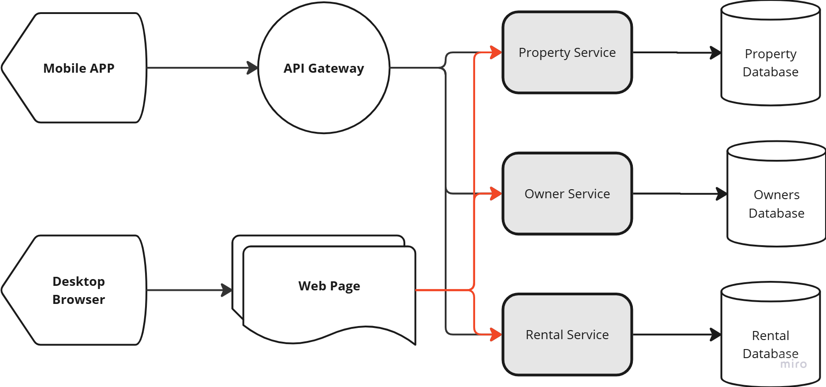
Figure 7 - Simplified Microservice Architecture
This agile approach enables teams to work autonomously, fostering faster innovation and more frequent releases. It is the approach that larger companies and corporations are adopting at a rapid pace due to these strengths overcoming the need for large teams to have complete domain knowledge.
Key benefits of microservices include improved fault isolation, enhanced scalability, and greater technology diversity. If one service fails, the rest of the application remains unaffected, unlike monolithic architectures where a single point of failure can bring down the entire system. Individual services can be scaled independently based on their specific resource requirements, optimizing resource utilization and reducing costs.
Furthermore, different services can be implemented using different technologies best suited to their specific needs, promoting technological diversity and avoiding vendor lock-in. This allows teams to choose the most appropriate technology for each service, rather than being constrained by a single technology stack for the entire application.
Despite the advantages, microservices introduce complexities in areas like inter-service communication, data management, and distributed tracing. Managing communication between numerous independent services requires robust mechanisms for service discovery, load balancing, and fault tolerance.
“Another issue with using the microservice architecture is that developers must deal with the additional complexity of creating a distributed system. Services must use an interprocess communication mechanism. This is more complex than a simple method call.” (Richardson, 2018)
Data consistency across different services can be challenging, requiring careful consideration of data synchronisation and eventual consistency strategies.
Monitoring and debugging a distributed system of microservices necessitates sophisticated tracing and logging tools to track requests across multiple services and identify performance bottlenecks.

2.5.2 Microservice Database Strategies.
Microservice database strategies are crucial for managing data effectively in a distributed architecture. Several patterns have emerged to address the challenges of data management in microservices.
The Database per Service pattern, a cornerstone of microservice architecture, advocates for each service owning its dedicated database which is shown in figure 7 above. This isolation ensures loose coupling and independent deployment, allowing teams to choose the most appropriate database technology for each service's specific needs. However, maintaining data consistency across services becomes more complex, often requiring eventual consistency strategies or Saga patterns for distributed transactions.
Another approach is the Shared Database pattern, where multiple services share a single database instance. While simpler to implement initially, this pattern can introduce tight coupling between services and limit independent scalability. Contention for database resources can also become a bottleneck as the system grows.
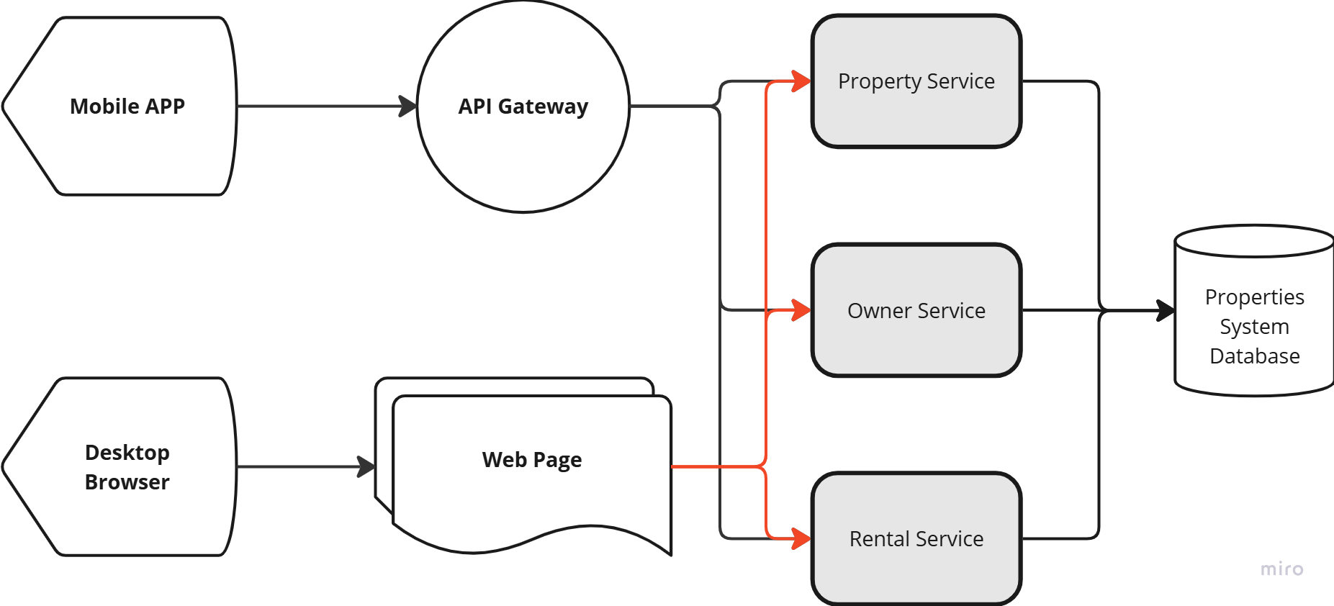
Figure 8 - Shared Database Microservice example
This pattern is generally discouraged for large-scale microservice deployments but can be suitable for smaller applications or during a transition from a monolithic architecture.
“The shared data pattern is a controversial pattern when we talk about microservices. It would certainly be considered an anti-pattern if we applied it to a green project. However, it is a pattern that should be considered as a temporary pattern for legacy applications that are in a transitional phase.”(Pacheco, 2018)
Unfortunately, the analogy of a temporary solution becoming a permanent solution is often applied when this pattern is used in commercial projects. Which often leads to issues with the scalability, maintainability, and independent deployment of the services, effectively negating many of the intended benefits of a microservices architecture. The tight coupling introduced by the shared database can lead to cascading failures and hinder agile development practices.
The API Composition pattern offers a way to retrieve and combine data from multiple services without directly accessing their underlying databases. Each service exposes its data through a well-defined API, and a composite service or API gateway orchestrates requests to retrieve and aggregate the required information. This approach maintains service isolation but can introduce latency due to network calls and data aggregation.
Domain-Driven Design (DDD) plays a significant role in shaping microservice database strategies. DDD emphasizes aligning service boundaries with business domains, which naturally leads to dedicated databases per service.
By focusing on bounded contexts within each domain, DDD helps ensure that each service owns and manages its data independently, promoting loose coupling and data autonomy.
This alignment between business domains and service boundaries simplifies data management and improves the overall maintainability of the microservice architecture. DDD principles also encourage careful consideration of aggregate roots and data consistency boundaries within each service, further refining the database strategy. (Baran, 2024)

2.5.3 Microservice Fault Tolerance.
Fault tolerance in microservices architectures is crucial due to their distributed nature and interdependencies. A single failing service, if not handled properly, can cascade through the system, leading to widespread outages.
Microservices must be designed to anticipate and gracefully handle failures, both within individual services and within the broader system. Key techniques for achieving fault tolerance include implementing retries with exponential backoff to handle transient errors, circuit breakers to prevent repeated calls to failing services, and employing health checks to monitor service availability.
Decoupling services through asynchronous communication patterns, such as message queues, can further enhance fault tolerance by preventing blocking operations and enabling services to continue functioning even when dependent services are unavailable.
Bulkheads, which isolate failures within specific service instances or groups, prevent a single point of failure from impacting the entire system.
Techniques like redundancy and replication, where multiple instances of a service are deployed, ensure availability even if some instances fail.
Load balancing distributes requests across these redundant instances, further improving resilience.
Implementing timeout mechanisms prevents indefinite delays when waiting for responses from potentially failing services. Therefore, comprehensive monitoring and logging are essential for quickly detecting and diagnosing failures.
These observability tools provide insights into system behaviour and facilitate prompt mitigation of issues.
By incorporating these fault tolerance strategies, microservice architectures can maintain availability and gracefully degrade functionality even in the presence of failures, ensuring a more robust and reliable system overall.

2.5.4 Microservice Database Consistency Challenges.
Maintaining data consistency across multiple microservices, each with its own dedicated database, poses a significant challenge. Traditional approaches relying on distributed transactions, such as two-phase commit, can struggle in the face of the decentralized and potentially heterogeneous nature of microservices.
These distributed transactions often introduce performance bottlenecks and can hinder the independent scalability and autonomy that microservices aim to achieve. Moreover, different microservices may utilize different database technologies, further complicating transaction management.
This distributed data management requires careful consideration of data ownership, synchronization mechanisms, and strategies for handling eventual consistency.
“So microservices use a distributed system to improve modularity. But distributed software has a major disadvantage, the fact that it's distributed. As soon as you play the distribution card, you incur a whole host of complexities.”(Fowler, 2024)
The move towards decentralized data management in microservices necessitates approaches that prioritize eventual consistency over strict, immediate consistency.
Techniques like Saga patterns, which orchestrate a series of local transactions across multiple services, offer a more flexible and resilient approach to managing data consistency in distributed environments.
Event-driven architectures, where services publish and subscribe to events related to data changes, enable loose coupling and asynchronous updates, facilitating eventual consistency.
Employing change data capture mechanisms allows services to react to changes in other services' data without tight coupling.
Choosing the appropriate consistency model depends on the specific requirements of the application, balancing the need for consistency with the performance and scalability benefits of microservices.
It is crucial to define clear service boundaries and data ownership to manage data effectively in a distributed microservice architecture.

2.5.5 Microservice Saga Pattern Implementation.
Implementing the Saga pattern for distributed transaction management in microservices involves two primary approaches: orchestration and choreography.
In the simplest form the Saga pattern is implemented as the following.
“When one local transaction fails because of not complying with the business rules, a series of compensating transactions will be executed by saga to undo the changes that were made by the preceding local transactions” (Daraghmi, Cheng-Pu and Yuan, 2022)
Orchestration-based sagas utilize a central orchestrator that manages the sequence of transactions across participating services. The orchestrator sends commands to each service to execute its local transaction and handles any necessary compensation actions in case of failures.
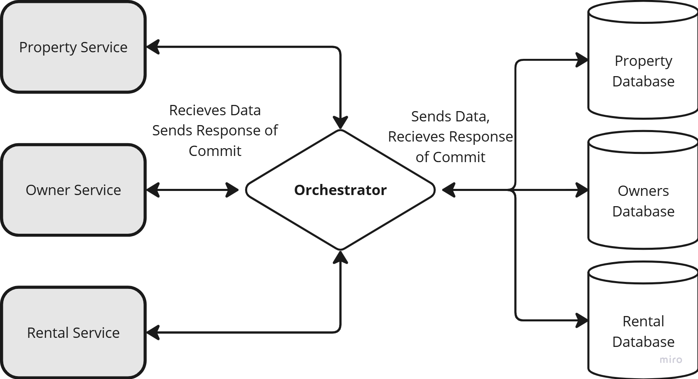
Figure 9 - Simplified Saga Orchestrator
This centralized approach simplifies the logic within individual services but introduces a potential single point of failure. The orchestrator must be designed for high availability and fault tolerance. Orchestration offers better visibility into the overall saga execution flow, making debugging and monitoring easier. However, it can increase coupling between the orchestrator and participating services.
Choreography-based sagas, in contrast, rely on decentralized coordination. Each service listens for events published by other services and performs its local transaction based on these events. This decentralized approach eliminates the single point of failure of the orchestrator and promotes loose coupling between services.
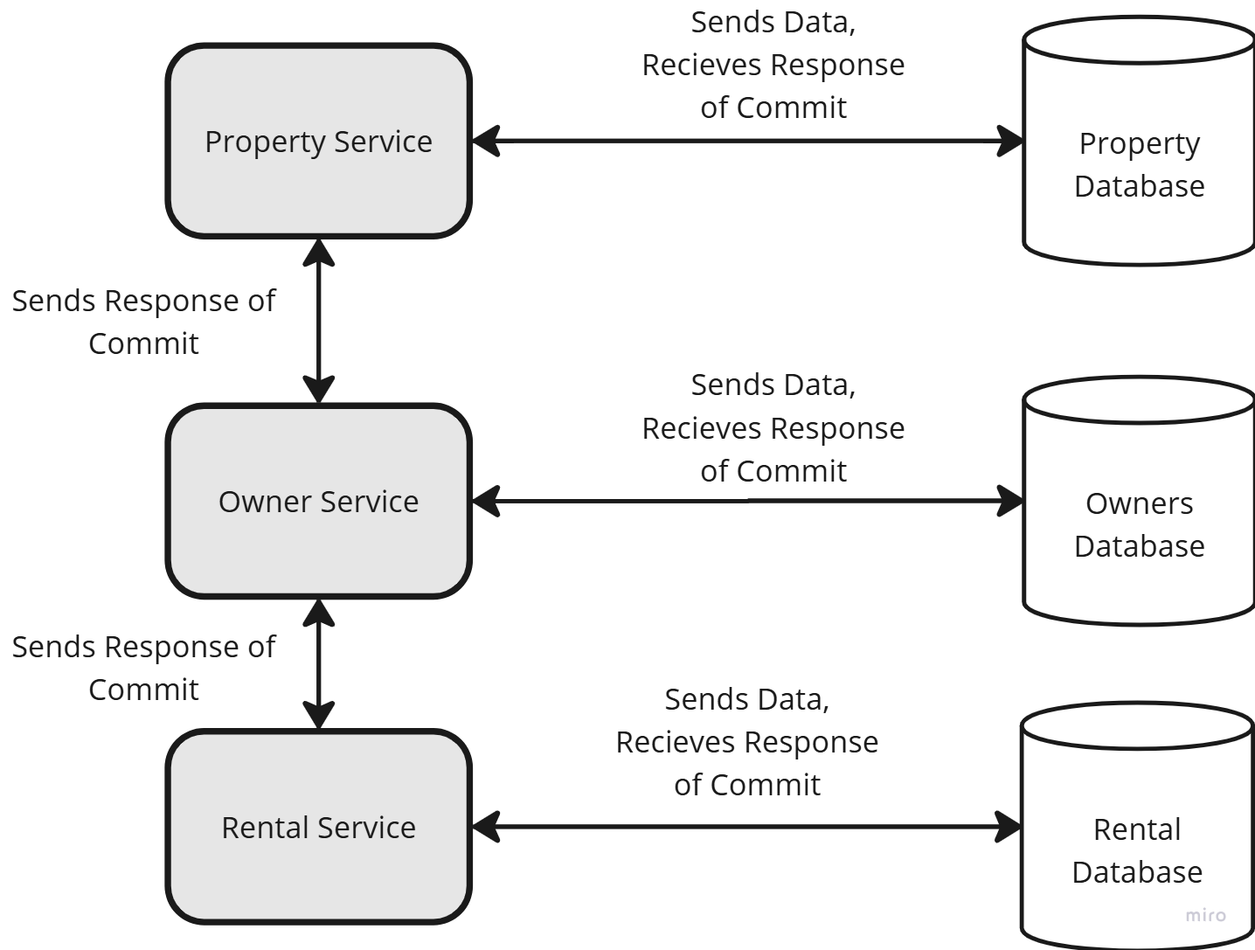
Figure 10 - Simplified example of Choreography Saga Pattern.
However, it can increase complexity as the overall transaction flow is distributed across multiple services, making it harder to track and debug. Choreography requires careful design of the event flow and error handling mechanisms to ensure the eventual consistency of the system.
Choosing between orchestration and choreography depends on factors such as system complexity, the need for centralized control, and the level of coupling desired between services. Each approach has trade-offs regarding complexity, fault tolerance, and maintainability. Careful consideration of these trade-offs is crucial for successful Saga pattern implementation.

2.5.6 Microservice Event Driven Implementation.
Implementing event-driven architectures in microservices leverages asynchronous communication patterns where services publish and subscribe to events representing significant changes in the system's state.
This approach promotes loose coupling between services, as publishers are unaware of the subscribers consuming their events. Microservices communicate indirectly through a message broker or event bus, enhancing scalability and fault tolerance.
Services can react to events independently without direct dependencies, fostering flexibility and allowing for easier evolution of the system. Commonly used messaging platforms like Kafka, RabbitMQ, and ActiveMQ provide robust infrastructure for managing event streams. Defining a clear event schema, including the structure and semantics of events, is crucial for interoperability between services.
Event-driven architectures facilitate eventual consistency by allowing services to update their local state asynchronously in response to events. This approach is particularly well-suited for scenarios where immediate consistency is not strictly required.
However, it introduces challenges related to handling eventual consistency issues and ensuring data integrity across services. Implementing mechanisms for handling duplicate events and ensuring message ordering becomes essential for reliable event processing.
Idempotent consumers, designed to handle the same message multiple times without unintended side effects, help mitigate issues with duplicate events.
“In a world full of retried messages, idempotence is an essential property for reliable systems. Idempotence is a mathematical term meaning that performing an operation multiple times will have the same effect as performing it exactly one time.”(Helland, 2012)
Monitoring and tracing event flows are crucial for debugging and understanding system behaviour in an event-driven architecture. Effective schema management and versioning strategies are vital for maintaining compatibility between services as the system evolves.

Chapter 3: Database Technologies & Real-world Examples.

3.1 Database Technologies

3.1.1 Object Relational Mappers (ORMs).
Object-Relational Mappers (ORMs) bridge the gap between object-oriented programming paradigms and relational databases.
They provide a way to interact with databases using objects rather than writing SQL queries directly. This abstraction simplifies database operations within applications, improving developer productivity and code readability.
ORMs map database tables to classes and table rows to objects, allowing developers to manipulate data using familiar object-oriented concepts. This simplifies complex data relationships and reduces the risk of SQL injection vulnerabilities by abstracting away direct SQL manipulation. Popular ORMs include Hibernate for Java, SQLAlchemy for Python, and Entity Framework for .NET.
However, using ORMs introduces a layer of abstraction that can impact performance if not carefully managed. Complex queries can sometimes be less efficient when translated through an ORM compared to hand-optimized SQL.
Understanding the underlying SQL generated by the ORM is crucial for optimizing database interactions. Additionally, the initial setup and configuration of an ORM can introduce some complexity to the development process.
Despite these potential drawbacks, the benefits of improved developer productivity, enhanced code maintainability, and increased security often outweigh the performance considerations, making ORMs a valuable tool in many software development projects.

3.1.2 Database Consistency – Blockchain
Maintaining consistency in distributed databases is a complex issue. Blockchain technology, with its inherent structure of linked data blocks, offers a potential solution for enhancing consistency in these systems.
Each block in a blockchain contains data and is linked to the previous block, creating a chronological and tamper-proof chain of transactions. This structure is crucial for ensuring data integrity and consistency across the distributed system.
“Blockchain consists of a chain of blocks. Each block contains data or records of interests... and is linked to the previous block in the chain by a hash pointer data structure.”(Tseng et al., 2020)
This linking mechanism is fundamental to how blockchain strengthens consistency by providing a verifiable and ordered sequence of transactions.
Figure 11 - Blockchain Example Block (Tseng et al., 2020)
Tseng et al. (2020) also recognize the difficulties of integrating blockchain into IoT systems, citing issues like substantial computational demands, increased latency, limited scalability, and excessive network traffic. This overhead primarily arises from the need to validate each block, a process crucial for maintaining the blockchain's overall integrity and consistency.
Despite these challenges, the benefits of blockchain for database consistency can be advantageous in certain scenarios, especially in systems with sufficient computational resources.
For example, the Bitcoin system utilizes “mining” to distribute the computational workload required for validation. The paper provides a deep analysis into the technology including Bitcoin's architecture and its underlying protocol, the Bitcoin Backbone Protocol (BBP).
The core concept of linked data for enhanced consistency, inherent in blockchain, can be adapted and applied to existing database replication techniques.
By incorporating timestamps and metadata, similar to the way blockchain links blocks together, consistency in replicated databases can be improved. This would require adjustments to traditional server architectures and data synchronization protocols.
Tseng (Tseng et al., 2020) further explores this by proposing an augmented BBP-database model, demonstrating the potential of integrating blockchain concepts into established database systems to enhance consistency.
This augmented model achieves read-my-write and eventual consistency, offering a practical example of how blockchain principles can be applied to improve traditional database approaches.

3.1.3 Database Middleware.
Database middleware plays a crucial role in today's data-driven landscape, enabling consistent data synchronisation and translation between diverse database systems.
Its applications span various scenarios, including bridging the gap between relational databases like Microsoft SQL Server and NoSQL databases such as MongoDB or CouchDB. Beyond mere data transfer, middleware can be implemented to enforce data consistency and creating business logic checkpoints, ensuring that unacceptable data does not enter the database.
For instance, writes to a primary database are often routed through the middleware before being propagated to replica data stores. This intermediary step allows for enhanced security and data validation.
“Hihooi is a new replication-based master-slave middleware system that is able to overcome the aforementioned limitations and offer workload scalability, strong consistency, and elasticity for transactional databases”(Georgiou et al., 2021)
Middleware can also be used to analyse incoming data, ensuring it adheres to security protocols and data integrity constraints before it is committed to the primary database. This process adds a layer of control and validation, safeguarding data quality and system integrity throughout the replication process.
Furthermore, middleware can facilitate complex transformations and mappings between different data models, enabling seamless integration between heterogeneous database environments.

3.1.4 Change Data Capture.
Change Data Capture (CDC) is a set of techniques used to identify and track changes made to data in a database. It is crucial for various tasks, including data synchronization, data warehousing, auditing, and creating real-time data pipelines. CDC enables applications to react to data modifications as they occur, rather than relying on periodic snapshots or batch processing.
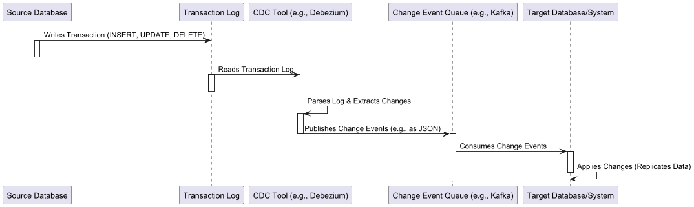
Figure 12 - Change Data Capture Sequence Diagram
This allows for more timely insights and more responsive applications. Several approaches exist for implementing CDC, including trigger-based methods, log-based methods, and diff-based methods. Each approach has its own trade-offs in terms of performance overhead, complexity, and data accuracy.
Log-based CDC, for example, often leverages the database's transaction log for efficient tracking, while trigger-based approaches involve custom code execution for each change, potentially impacting database performance.
“Relational databases normally keep a log containing all operations performed. An approach to extract changed data is to analyze the transactional log and extract deltas from it. This technique is called Database Log Scraping. Database Log Scraping uses the database’s redo log to detect transactions that affect the tables under consideration”(Schmidt et al., 2015)
Modern database systems increasingly offer built-in CDC capabilities. For instance, databases like PostgreSQL offer logical decoding, which allows applications to subscribe to a stream of changes. Apache Kafka (apache.org, 2024) is frequently used in conjunction with CDC to create robust, scalable data pipelines, enabling real-time data integration and analysis.
Debezium (Debezium.io, 2024), is an open-source platform specifically designed for CDC, supporting various database systems and providing pre-built connectors for easy integration with Kafka and other streaming platforms
The rise of cloud-based databases and data warehousing solutions has also led to the development of cloud-native CDC tools that simplify the process of capturing and streaming data changes from cloud databases. These advancements simplify the implementation of CDC and expand its applicability across various data architectures.

3.1.5 Edge Databases & Datastores.
Edge databases and datastores address the limitations of centralized cloud databases by bringing computation and storage closer to data generation, improving latency, bandwidth usage, and data sovereignty.
“These applications often require massive data computations/processing and have strict low/ultra-low latency requirement. Nevertheless, deploying such applications on mobile devices is still a challenging problem, primarily due to their hardware limitations.”(Zhang and Debroy, 2023)
This highlights the need for edge resources to handle the demands of modern applications, particularly in resource-constrained environments like mobile devices. Processing data locally at the edge allows faster application responses, reduced network traffic, and offline operation.
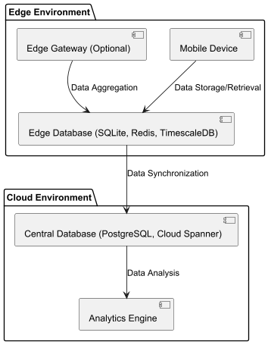
Figure 13 - Edge to Cloud Data transference, Component Diagram
These capabilities are valuable in fields like IoT, content delivery, industrial automation, and remote monitoring, where real-time responsiveness and resilience are critical. Edge databases are designed for resource-constrained environments, focusing on efficiency and a small footprint.
Edge databases come in different forms, from lightweight relational databases for smaller devices to NoSQL datastores tailored for specific data structures. Time-series databases, for instance, are excellent for managing sensor data at the edge.
Data synchronization between edge and cloud is essential for edge database architectures and efficiently transmitting edge data to a central repository is vital for broader analysis.
Combining data from multiple edge databases through a Database Merging strategy allows a unified view and complex analysis. However, this introduces challenges like data consistency, schema integration, and distributed query optimization.

3.1.6 Immutable & Append Only Databases.
Immutable and append-only databases represent a paradigm shift in data management, prioritizing data integrity and auditability.
In these systems, data is never updated in place; instead, new data is appended as a new version or record. This approach preserves the entire history of data changes, creating a comprehensive audit trail and enabling point-in-time queries.
Immutable databases are particularly well-suited for applications requiring strong data provenance, such as financial systems, legal record keeping, and version control systems.
While traditional databases focus on efficient updates and current state representation, immutable databases emphasize data history and verifiability. This characteristic simplifies data recovery and eliminates the risk of data corruption from accidental or malicious updates.
The append-only nature of these databases facilitates efficient data replication and synchronization. New data can be easily streamed to replica nodes without the complexities of managing concurrent updates.
Therefore, immutability simplifies concurrency control as there are no data conflicts to resolve. However, implementing efficient querying and storage management in immutable databases requires specialized techniques.
“An immutable file has an identity and contents, neither of which can change.
You can copy an immutable file whenever and wherever you want and share the immutable copies across users” (Helland, 2015)
While immutability offers significant advantages for certain applications, it is not a universal solution. Applications requiring frequent updates and in-place modifications might find traditional mutable databases more suitable.
The adoption of Immutable databases is still in its infancy, with one notable exception of ImmuDB (ImmuDB, 2024), which is the leading open source immutable database currently.

3.2 Case Studies & Example white papers.

3.2.1 Data Consistency issue during work placement.
While undertaking work placement a situation occurred where a system was running 3 replications of a CouchDB database. For the most part, this system was functioning without issues, in theory and QA testing there were no faults found relating to inconsistencies in the database.
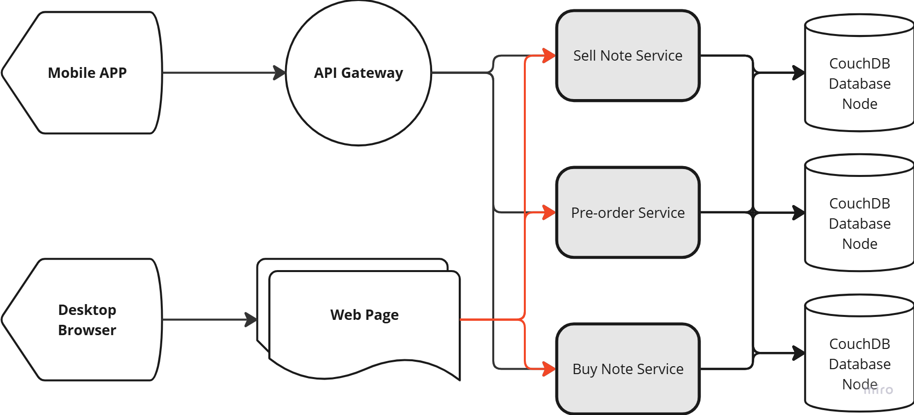
Figure 14 - Example of till services with three CouchDB Nodes
However, it was found that during one process of updating preorders sometimes the data was corrupted, and a single transaction was doubling in value leaving the currency in question to be out of line with actual figures. This corrupt value was identified, and a data fix was implemented to resolve the issue.
A Root Cause Analysis (RCA) was undertaken to identify the underlying issue with the incident, the low rate of occurrence meant that this was an edge case issue and that would in turn extensive review & testing to identify the related cause and potential fix.
A series of JMeter load tests were created to simulate the issue, as well as manual testing was undertaken by the QA team, it was discovered that if the same till system was opened on two separate machines and the same pre-order was processed each machine would post to a different instance of CouchDB.
Thus, the inconsistency problem was due to how the database replication was handled by CouchDB which emphasises eventual consistency in such matters, the problem with this matter was that the replication termination protocol was choosing a combination of the updates as it would apply one update and then the other on top of it therefore causing the transaction to occur twice.
The resolution was to reduce the CouchDB instances down to one node thus removing the replication and partition tolerance of the system, further load testing was undertaken to ensure that a single instance of CouchDB on a high-spec cloud node would be able to handle the system load.
This returned a positive response in terms of historical data of transaction load on the overall system as a transaction rate of three times the previous year's highest transaction day was placed on the system and all transactions were able to make it into the database without issue.

3.2.2 Challenges with migrating Legacy software to Microservice Architecture – A review of two Papers on this topic.
Both papers discuss challenges related to migrating legacy systems to microservices architectures, with a particular focus on data-related concerns. However, they approach these challenges from slightly different angles.
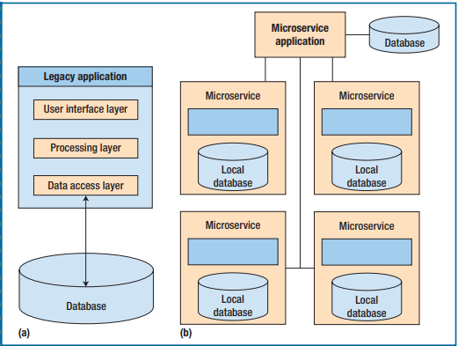
Figure 15 - Comparing (a) a legacy (e.g. monolithic) architecture and (b) a microservice. (Furda et al., 2018)
The paper “Migrating Enterprise Legacy Source Code to Microservices” (Furda et al., 2018) focuses specifically on three core challenges of multitenancy, state-fulness, and data consistency. Regarding databases, the paper emphasizes the need for data isolation in multitenant environments.
“While the application instances are shared, the tenant data must be separated and must be accessible only by the tenant that owns it.”(Furda et al., 2018)
It further discusses the complexities of migrating legacy code interacting with a centralized database to a microservices architecture relying on decentralized data repositories, highlighting the data consistency challenges that arise.
The paper proposes strategies like tagging tenant data and utilizing specific design patterns (Two-Level Data Mapping Gateway, Strategy pattern, Two-Step-View) to address these challenges.
The paper “Evolving Software Architectures from Monolithic Systems to Resilient Microservices”(Kaloudis, 2024) takes a broader approach, discussing the overall evolution of software architectures from monolithic to SOA and then to microservices.
While also touching upon data consistency.
“However, maintaining data consistency across distributed services presents significant challenges. Techniques like event sourcing and the Saga pattern are often employed to ensure synchronized, up-to-date transactions across services.”(Kaloudis, 2024)
It places more emphasis on general architectural concerns like API management, testing strategies, and the adoption of emerging technologies like Kubernetes and AIOps (Artificial Intelligence for IT Operations).
The paper analyses case studies of large companies like Netflix and Amazon, using their experiences to derive best practices for microservices adoption.
Database-specific discussions are less detailed compared to the first paper, focusing more on the distributed nature of data and the associated complexities.
In summary, the paper by Furda et. al. offers a more in-depth exploration of specific database-related challenges in microservices migration, including practical coding-level considerations.
The paper by Kaloudis provides a broader overview of architectural evolution and best practices, with data consistency being one among several discussed challenges.
Both agree that data management in distributed microservices environments is a significant concern requiring careful consideration.

3.2.3 White paper on challenges of microservices by JBS Software Solutions.
The white paper, “Microservices: The Good, The Bad, and The Better,” by JBS Custom Software Solutions (JBS Dev, 2024), highlights several challenges related to databases in microservices architectures.
One key challenge is the complexity of reporting and analytics. Traditional business intelligence (BI) solutions rely on a central data repository.
Decomposing a few monolithic applications into numerous microservices significantly increases the number of data sources for BI to pull from, adding complexity. The paper also cautions against using denormalized data for analytics, even if it is used within the microservices for efficiency.
“For analytics, you should avoid using a de-normalized copy of the data, even though there are situations where your microservices may need it for efficiency. If you de-normalize your User or Customer data into your Order service, you should never have that service send such data to your analytics or BI component: it's not the system of record.”(JBS Dev, 2024)
Another challenge arises from the use of denormalized data and asynchronous updates within the microservices themselves.
While denormalization can improve performance within a given microservice, it can lead to data inconsistencies. If a piece of information changes in the system of record, it takes time to replicate that change to all denormalized copies, which can cause issues for real-time interactions.
“One way to address [performance issues from multiple services interacting] is to de-normalize the customer data into the order data. However, what happens when a key piece of customer data changes, such as someone getting married and changing their name?”(JBS Dev, 2024)
Essentially, while each microservice has its own independent database optimized for its specific needs, managing data consistency and efficiently extracting insights across these distributed databases becomes more complex.
While this white paper focuses on possible solutions and highlights some key database issues within the microservice architecture, it offers little to no concrete solution. The validity of their claims is also brought into question as this white paper has not been peer reviewed and therefore it can only be taken as an insight into some of the issues that may arise in enterprise microservice solutions.

3.2.4 Databases at Scale: Challenges in a Microservices Architecture - The Spotify Data Platform.
This research explores the challenges of managing data at scale within a microservices architecture, drawing heavily on the experiences documented by Spotify in their “Data Platform Explained” series Part I: (Spotify Engineering, 2024a) and Part II: (Spotify Engineering, 2024b).
Data Volume and Velocity, A primary challenge is the sheer volume of data generated and the speed at which it flows through the system. Spotify processes a staggering 1.4 trillion data points daily highlighting the need for a robust and scalable infrastructure capable of handling this influx. This volume necessitates efficient data pipelines, distributed data storage, and robust data processing capabilities.

Data Management and Processing, Organizing, attributing, and securing data effectively is crucial. Spotify emphasizes data management focusing on data attribution and privacy, ensuring the integrity and security of Spotify's data. (Spotify Engineering, 2024a).
This involves establishing clear data governance policies, access controls, and data lineage tracking mechanisms across various services. Additionally, efficient data processing pipelines are required to transform raw data into usable formats for analysis and decision-making. Spotify uses a combination of Big Query, Flink, Dataflow, and their own Scio (a Scala API for Beam) to handle these tasks.
Maintaining Data Consistency and Integrity, data consistency becomes a significant challenge as data is distributed across multiple services. Ensuring that data remains consistent and accurate across different databases and services requires sophisticated synchronization mechanisms and strategies for handling eventual consistency.
Organizational and Cultural Challenges, implementing a robust data platform requires more than just technology. Spotify stresses the importance of building a culture around the data platform. (Spotify Engineering, 2024b).
This involves fostering collaboration between teams, establishing clear documentation and onboarding processes, and creating a community where knowledge sharing and problem-solving are encouraged. Furthermore, Spotify highlights the need to automate all possible toils and migrations to minimize disruption and ensure seamless upgrades. (Spotify Engineering, 2024b)
Scalability and Flexibility, the platform needs to be adaptable to changing business requirements and capable of scaling to accommodate increasing data volumes and velocity. Spotify's evolution from managing a single Hadoop cluster to a multi-faceted data platform on GCP demonstrates this need for scalability and adaptability.
By examining Spotify's journey, it can highlight the key considerations and potential solutions for organizations grappling with the challenges of data at scale in a microservices environment.
Spotify's experience serves as a valuable case study for navigating the complex interplay of technology, processes, and culture required to build a successful data platform.

3.2.5 Replication Methods Implemented in MongoDB
MongoDB employs replication to ensure high availability and data redundancy. The core replication model is based on a primary-secondary architecture, similar to a master-slave relationship, but significantly enhanced in the Replica Set implementation.
In the simpler deployments, a single primary node handles all write operations, while secondary nodes asynchronously synchronize data from the primary and serve read operations.
“Write operation implement on Master, Slaves will send the synchronize data command asynchronously to Master to update its data”(Gu et al., 2015)
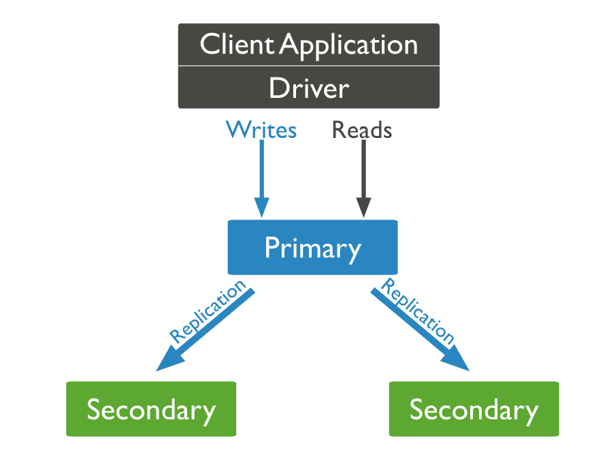
Figure 16 - Mongo DB simple replication with one primary node and two secondaries.(MongoDB, 2024)
This fundamental principle of a primary handling writes and secondaries replicating for reads is consistent across MongoDB's replication strategies.
The Replica Set model extends this primary-secondary architecture to provide automatic failover and increased robustness.
“Replication exists primarily to offer data redundancy and high availability. We maintain the durability of data by keeping multiple copies or replicas of that data on physically isolated servers” (MongoDB, 2024)
A Replica Set consists of multiple nodes, one designated as primary and the others as secondary, all maintaining identical data copies. The primary handles writes, which are then replicated to the secondaries using an operation log (OpLog), enabling efficient and consistent synchronization based on logical write operations.
The blog post “Optimizing for Fast, Responsive Reads with Cross-Region Replication in MongoDB Atlas” highlights the benefits of read-only secondary nodes within replica sets for performance optimization, allowing customers to optimize for local reads which minimize read latency. (Gordon, 2024)
Within a Replica Set, if the primary node fails, an election process automatically promotes one of the secondaries to primary, ensuring continuous operation. This election relies on a priority-based voting mechanism among replica set members, combined with the comparison of the last operation times (MaxAppliedOpTime).
“An election of primary will be held… First check the priority of each node with the highest is the primary, otherwise the consensus protocol will compare the MaxAppliedOpTime on each node, the latest is the primary” (Gu et al., 2015)
This is a simplified version of Paxos voting, by being direct and deterministic in the election process it ensures a quick election, minimizing downtime and preserving data consistency.
MongoDB’s choice of removing the ability to write to secondary nodes is to restrict the potential issues with data consistency, this trade off is justified by the fact that while replication can greatly enhance read availability Writes will still need to be propagated throughout the system to all nodes.
While one can argue that the fault tolerance of the system is lowered by this, Mongo decided to approach this issue with the view of speed to re-election of the next best secondary node. It does not prevent all data inconsistencies such as in the case of when the down master nodes comes back online, but takes the next best approach of ensuring data consistency by restriction and the implementation of replica sets.

Chapter 4: Justification, Methodology & Project Scope.

4.1 Research Question
Why is there a divide between the Theoretical definition of Microservice Architecture when it comes to Databases and their Implementation?
A serval fold problem within Distributed Databases that can be fragmented into issues regarding Database Administration, Fault Tolerance, Data Consistency and Data Replication.
This paper aims to explore these pain points within the realm of distributed databases.

4.2 Project Proposal
The project aims to create a Distributed Database Management System (DDBMS) which will allow end users to topographically decide Database Replication strategies, direction and consistency protocols. This Database Replication middleware will de-couple the replication strategy away from the DBMS and create a flexible and configurable environment.
The goal is to create a Graphical user interface to allow users to design a replication architecture and orchestrate database relationships that can implement specific replication methodologies (Asynchronous or Synchronous Replication) as well as the direction of data transfer throughout the system.
The Master-Master replication relationship will be the standard inferred relationship for bi-directional connections and similarly for uni-directional connections will be implicitly Master-Slave orientated due to the nature of data flow in one direction only.
The implementation of database consistency strategies will also be configurable from the database topology view. Allowing for the databases within the system to enforce a greater level of data consistency as opposed to a normal database setup.
These consistency techniques may include the addition of timestamp-based consistency measures, immutable records and possibly a variance on the Blockchain Technology consistency method.
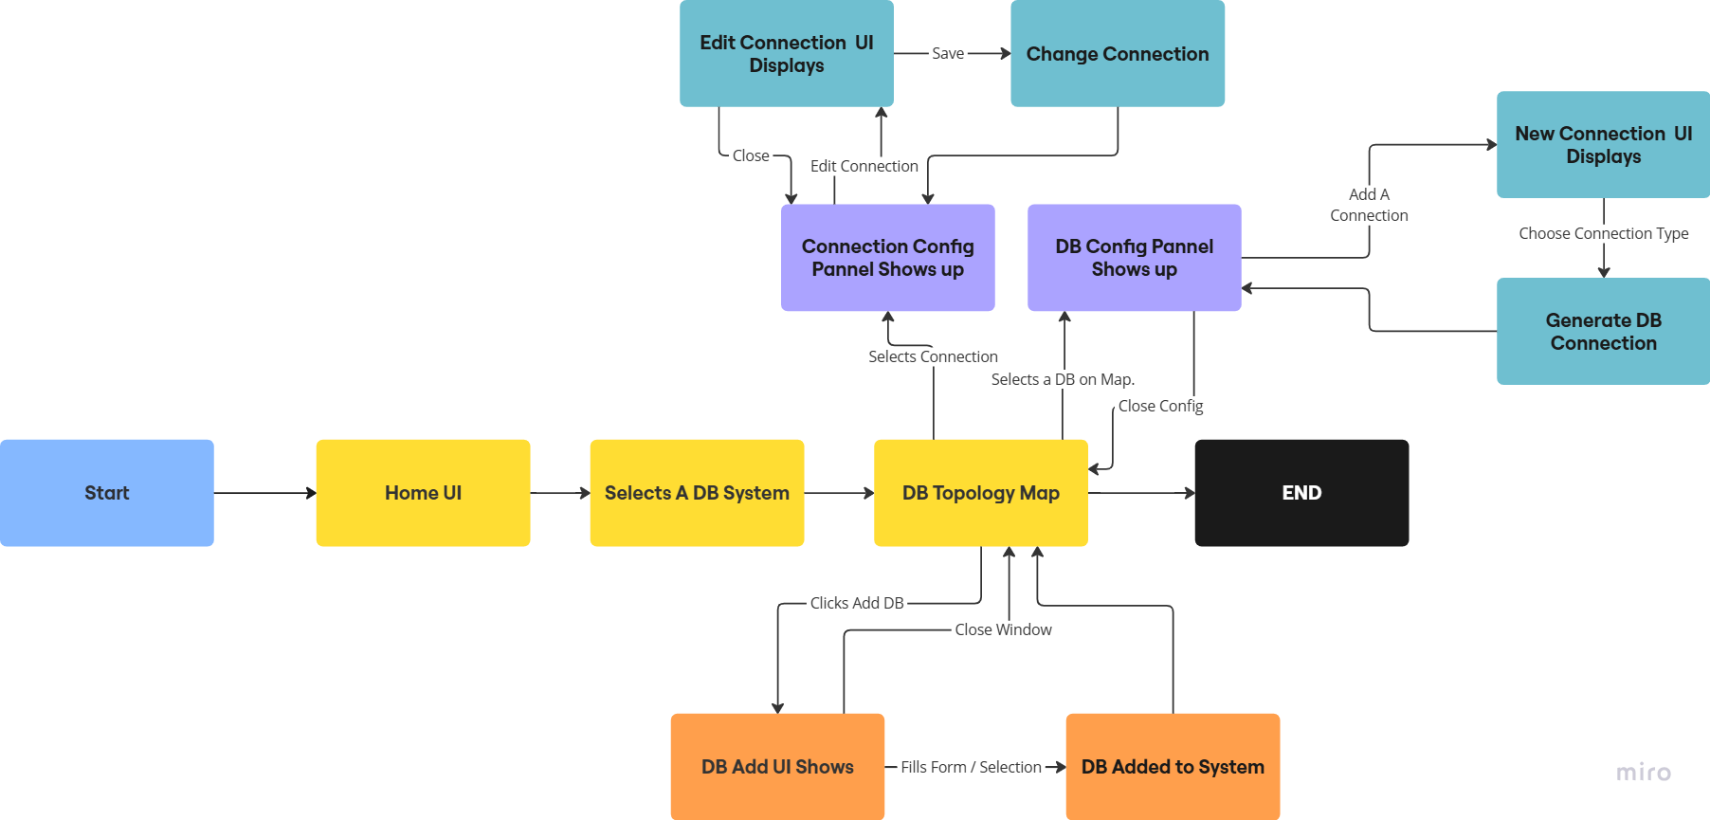
Figure 17 - High level overview of system functionality

4.3 Justification
The theoretical implementation of the Micro Service architecture implies that each microservice on the system has its associated database. However, this implementation can become hard to manage because each database requires its unique connection point, administration, security, and consistency strategy.
The overhead of administration of these small, scattered databases means that many implementations of the microservice architecture do not follow this approach and instead opt for one database that all the microservices connect to and feed into different tables.
This again introduces the bottleneck of a single database storing all the data, which will then need to be scaled either vertically or horizontally to alleviate connection stability and availability.
The proposed system intends to tackle a small section of this problem by allowing the end user to create a database topology from which they can then choose how the data in the distributed system is transferred, replicated or aggregated into databases extrapolated from the individual microservice or distributed system.
The advantages of this system are severalfold in terms of management and understanding of the system’s data at large.
The externalisation of the replication strategy allows for the microservice’s instances to be linked together, when one of the instances is down the other can still be reached and when the instance comes back online the replication middleware will compare the differences between this node and the others on the system, updating records if needed. As shown in the following diagram.
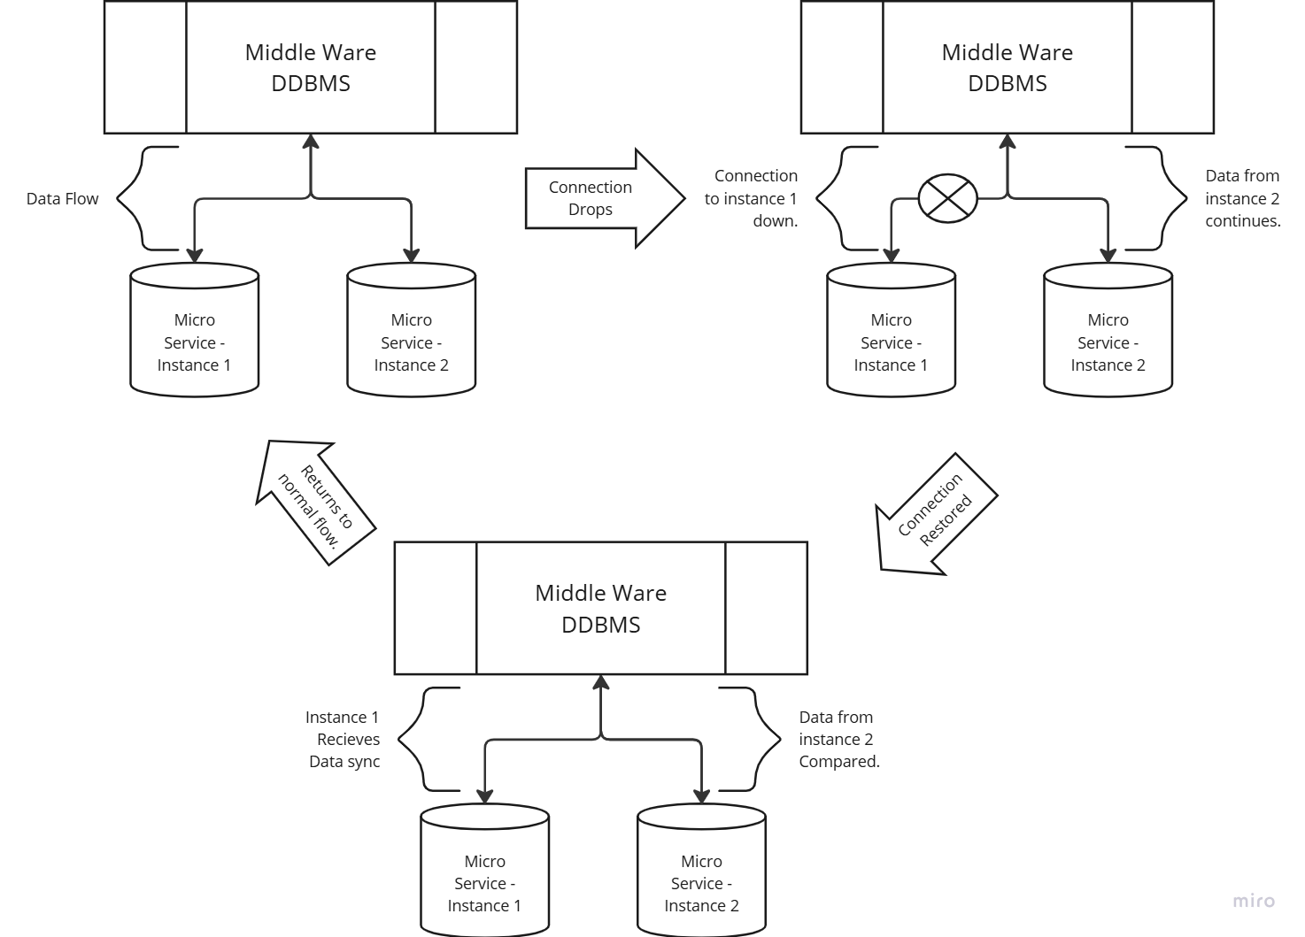
Figure 18 Microservice Middleware Replication example.
Furthermore, by allowing replication of edge databases into a larger database the system will enable the end user to gain a greater understanding of the overall system.
For example, in a till system that has each till as a microservice implementation, in order the get an overview of overall business profits or accounts this data will need to be collected and aggregated which may become unmanageable in a distributed database system. The proposed system would allow these databases to be aggregated into a central data store that the accountancy or auditing team can access.
Another aspect of the system is that it takes a layered approach to the problem presented by the CAP theorem. As Partition Tolerance is usually a necessary part of a distributed system, the fact that a node may be unreachable, having another replicated node available to take queries in such an event is necessary.
Whereas in a microservice if the database is solely for that service this may not have been replicated, therefore in industry we find that partition tolerance is only applied to a larger database from which multiple microservices get their respective data such as in the shared database structure.
By decoupling the replication of the database, we can allow smaller databases to have a replicated node that could be load balanced to receive traffic in the event of a lost node allowing for Availability of the data.
Extrapolating the Consistency strategies to apply directly to the database. By employing eventual consistency for database replication, the system avoids the immediate requirement for perfect data synchronization across all nodes.
This allows for flexibility in data propagation, relying on the chosen consistency strategy, such as immutable data or blockchain integration, to ultimately ensure data integrity across the distributed database.

4.4 Agile Development, & Jira as a Monitoring Tool.
This project will follow the Agile Software Development Lifecycle which follows the Agile manifesto described on Agilemanifesto.org (Kent Beck et al., 2024), while implementing the industry standard of 2-week sprints. Each sprint will have a limited number of tasks undertaken based on the hours estimated for each task, 22 hours per week have been allocated towards project work giving 44 hours per sprint of backlog capacity.
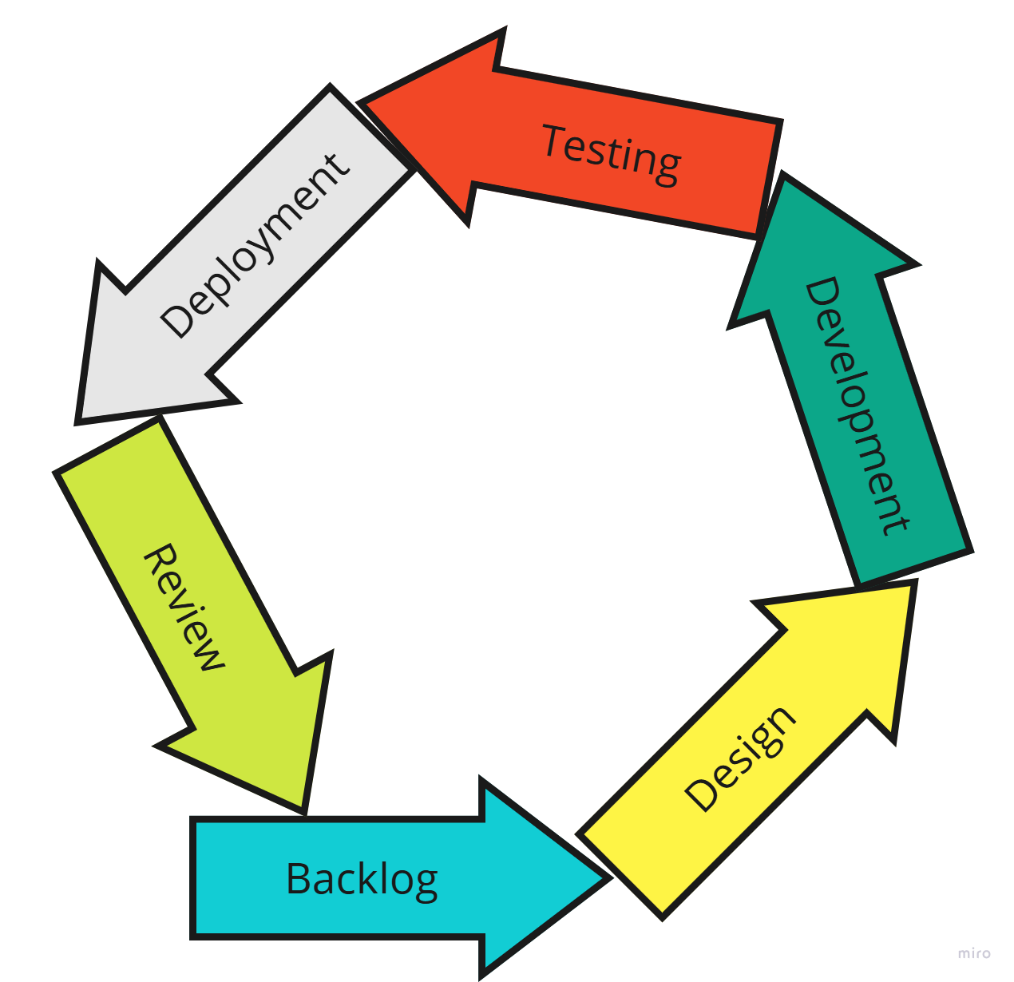
Figure 19 - Agile Software Development Life Cycle.
Jira's selection as a project tracking tool is justified due to its comprehensive features that align with agile project management methodologies.
Jira's structure allows for the organization of work items through hierarchical structures like Epics, which represent large bodies of work, broken down into smaller, manageable User Stories. These User Stories function as individual tasks, providing granular tracking of progress.
Furthermore, Jira facilitates sprint planning and execution by enabling the definition of time-boxed iterations, known as sprints, with specific start and end dates. This allows teams to focus on delivering a defined set of features within a given timeframe.
This structure also promotes transparency, accountability, and iterative development, key components of agile methodologies. The ability to track progress against these sprints allows for improved predictability and adaptation throughout the project lifecycle.

4.5 Methodology, Steps to improving Data consistency in Distributed Database’s.
The methodology for creating the Distributed Database Management System (DDBMS) will follow an iterative, agile approach using two-week sprints managed in Jira as mentioned above.
The initial step involves developing a middleware layer to serve as the core management system. This middleware will handle database registration, allowing users to input connection details for both relational and NoSQL databases.
Concurrently, the graphical user interface (GUI) for designing replication topologies will be developed, enabling users to visually establish connections between registered databases.
Following this, the configurable replication module will be implemented, supporting both Synchronous and Asynchronous strategies, along with directional data transfer controls.
Integration of database consistency strategies will be addressed next, allowing users to select and configure consistency mechanisms for individual databases.
Finally, the database synchronization checker module will be developed to monitor data consistency across the distributed system, triggering alerts and corrective actions as needed.
Throughout the process, rigorous testing and refinement will be conducted within each sprint to ensure functionality and stability, covered in chapter 5.6.
After the creation of the DDBMS a series of JMeter load tests will be conducted to check the validity of the approach, comparing the writes and reads of the database to a replicated database, checking for delay of transfer of data.
These tests will also show if the system could handle a vast amount of write actions in a simulated environment, the created Sync Checker will then be able to see if the data written between the replicas is consistent and valid.
To ensure the validity of the above approach, a Prototype will first be constructed without the GUI which will test the connections between the DDBMS middleware and the chosen Open-Source SQL database (H2) (h2database.com, 2024). This prototype is explored in chapter 6.

4.6 Project Specification & Scope.
This project will focus on resolving the issues of Administration, Data Consistency and Replication within the microservice architecture as described by the theoretical approach of a database per service architecture.
By creating a central hub middleware system, the database network can be consolidated into a network topology of database configuration and connections between the various databases added to the system.
The Functional requirements for this DDRMS system are outlined below and will become the basis for the creation of the supporting design documentation and the system itself.
Heterogeneous Database Support, the system will accommodate both relational (e.g., H2, SQLite) and NoSQL (e.g., MongoDB, CouchDB) databases, reflecting the varied data persistence needs of microservices.
The initial target is to integrate at least two distinct relational and two distinct NoSQL database systems. This is to ensure that the essence of the distributed system environment is taken into account as in the theoretical approach to microservices is to have a separate database for each service and these may not necessarily be the same database system.
Visual Replication Topology Design, A user-friendly graphical interface will enable users to visually define the replication topology, specifying data flow and relationships between databases within the distributed system. This includes designating connections between databases, replication strategies and database consistency options.
Configurable Replication Strategies, the system will support both Synchronous and Asynchronous replication strategies, allowing users to choose the approach that best suits their performance and consistency requirements. Users will be able to configure parameters such as consistency level, conflict resolution mechanisms, and data synchronization frequency.
Directional Data Transfer Control, users will have granular control over the direction of data flow, enabling flexible configuration of unidirectional and bidirectional replication between databases. This allows for scenarios such as aggregating data from edge databases to a central repository (Database Merging) or propagating updates from a central database to edge instances.
Centralized Replication Management, the DDRMS will provide a centralized point of control for managing all replication processes within the system. This includes monitoring replication status, managing conflicts, and adjusting replication parameters. This centralized management simplifies administration and reduces the complexity of managing replication across a distributed environment.
Database Consistency Strategies, the system will allow users to select and configure different database consistency. This feature will provide flexibility in managing data consistency across the distributed database environment based on the specific needs of the application. Users will be able to define a choice of constancy strategies to be implemented on the selected database based on the available strategies implemented for that database type. This complements the existing configurable replication strategies by providing a higher-level control over how consistency is maintained across the replicated databases.
Database Sync Checking, to maintain data consistency, the DDRMS will implement database synchronization checks. These periodic checks will identify discrepancies between replicated copies and trigger corrective actions. Synchronization strategies under consideration include timestamp validation and logical consistency checks, with the optimal approach determined by the chosen replication method and application consistency needs.

Chapter 5: Design Documentation.

5.1 Jira User Stories.
This project utilizes Jira for project management, employing user stories and epics to capture and refine system requirements.
Due to the volume of user stories managed within Jira, only a representative sample is included in this documentation, See Appendix A for the full list of Jira user stories.
However, the following sections outline the key system features and functionalities derived from those user stories.
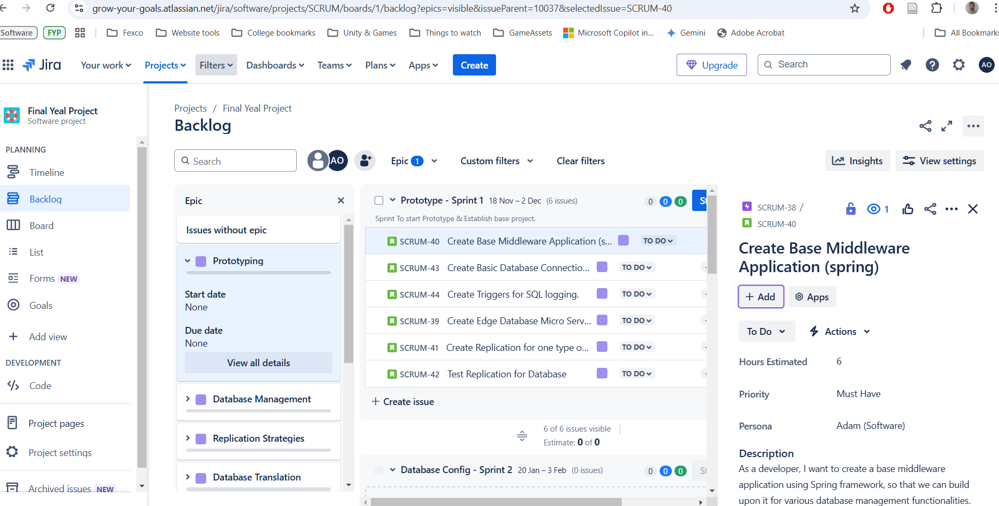
Figure 20 - Jira Dashboard overview

5.2 Use Case Documents, Activity Diagrams & Sequence Diagrams.

5.2.1 Adding a Database.

Use Case Name | Adding a Database
Use Case Id | 01
Context of Use | Database Admin wants to add a database to system.
Scope | System – Database Management
Priority | Must Have
Source | Core function
Primary Actor | DBA
Other Participating Actors | N/a
Description | DBA wants to add database to the system so that they can keep track of the microservices on the system.
Preconditions | None.
Success End Conditions | Database is recorded on the system, Connection valid.
Failed End Conditions | Database is not accessible via the system inputs.
Trigger | DBA adds a database.
Expected Scenario | DBA | System
 | Step 1:  Clicks Add Database.  Step 3:  DBA selects database type.  Step 5:  DBA enters in connection details and clicks submit. | Step 2:  System displays UI for DB connection.  Step 4:  System displays Form for connection string,  Password,  Username.  Step 6:  System attempts to connect to database via input credentials.  Step 7:  System received a correct response from database connection.  Step 8:  System Saves correct connection to memory and displays UI notification to show success.
Alternate Scenarios | DBA | System
 | Step 5:  DBA enters in connection details and clicks submit. | Step 6:  System attempts to connect to database via input credentials.  Step 7:  System received a failed response from database  Step 8:  System displays invalid connection details screen.  Returns to connection form.
Conclusions | A Database was Added to the system.
Post conditions | Database can now be configured on the system.
Business Rules | N/a
Implementation Constraints | N/a

Activity Diagram – Adding a Database.
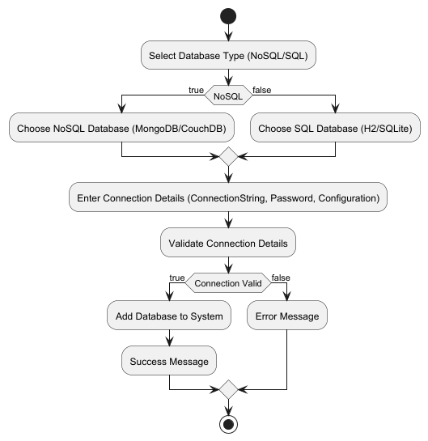
Figure 21 - Activity Diagram – Adding a Database.
Sequence Diagram – Adding a Database.
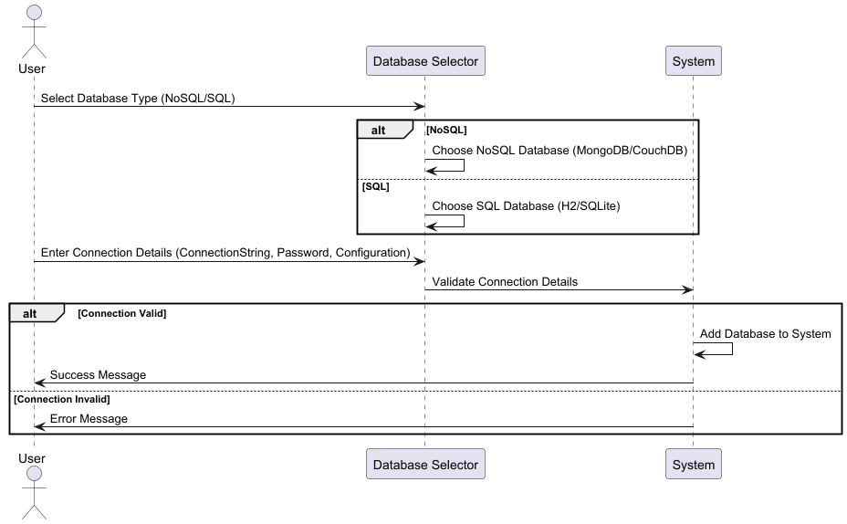
Figure 22 - Sequence Diagram – Adding a Database

5.2.2 Database Configuration.

Use Case Name | Configure a Database
Use Case Id | 02
Context of Use | Database Admin wants to edit the configuration of the database.
Scope | System - Database Management
Priority | Must Have
Source | Required Function
Primary Actor | DBA
Other Participating Actors | N/a
Description | DBA wants to edit the database connection details.
Preconditions | Database is already added to the system (Use Case 01)
Success End Conditions | Database Updated.
Failed End Conditions | Database Edits rejected.
Trigger | DBA clicks edit database.
Expected Scenario | DBA | System
 | Step 1:  DBA clicks edit database.  Step 3:  DBA clicks show Database connection.  Step 5:  DBA clicks Edit connection.  Step 7:  DBA enters updated details. | Step 2:  System displays Edit Database Configuration UI.  Step 4:  System Displays the Current connection Details.  Step 6:  System Displays Edit Database Connection details.  Step 8:  System attempts to connect to database via input credentials.  Step 9:  System received a correct response from database connection.  Step 10:  System Saves correct connection to memory and displays UI notification to show success
Alternate Scenarios | DBA | System
DBA enters incorrect connection details | Step 7:  DBA enters in connection details and clicks submit. | Step 8:  System attempts to connect to database via input credentials.  Step 9:  System received a failed response from database  Step 10:  System displays invalid connection details screen.  Returns to connection form.
Conclusions | Database Connection is updated.
Post conditions | N/a
Business Rules | N/a
Implementation Constraints | N/a

Activity Diagram – Configure A Database.
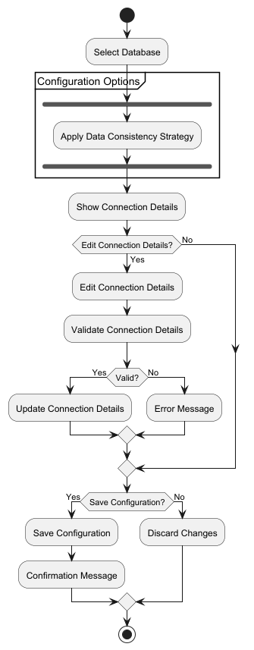
Figure 23 - Activity Diagram – Configure A Database.

Sequence Diagram – Configure a database.
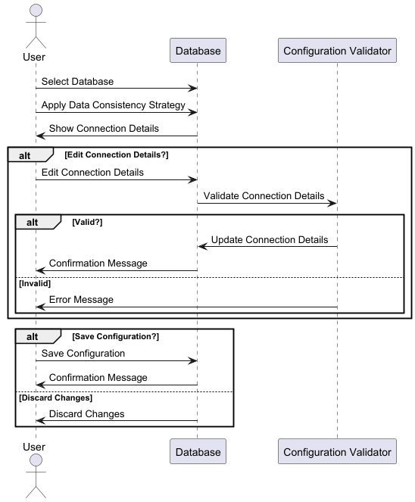
Figure 24 - Sequence Diagram – Configure a database.

5.2.3 Adding a Replication Strategy.

Use Case Name | Add a Replication Strategy
Use Case Id | 04
Context of Use | Database Admin, wants to apply a replication Strategy between two databases.
Scope | System - Database Replication
Priority | Must Have
Source | Requirements.
Primary Actor | DBA
Other Participating Actors | N/a
Description | Two Databases on the system have been chosen to replicate or transfer the data contained within them.
Preconditions | Two Database added to the system, of similar type.  One source and one target.
Success End Conditions | Database Replication commences between the two databases.
Failed End Conditions | Database Replication denied.
Trigger | DBA clicks add a connection
Expected Scenario | DBA | System
 | Step 1:  DBA clicks add a connection from the source database.  Step 3:  DBA Selects target database.  Step 5:  DBA Selects Replication type.  Step 7:  DBA fills in configuration details.  Step 10:  DBA Selects Tables for replication. | Step 2:  System displays the available target databases on the system that can be linked to the source database.  Step 4:  System displays available Replication types (uni-directional, bi-directional etc.)  Step 6:  System displays Replication Configuration Details.  Step 8:  System Validates configuration details. Displays success message.  Step 9:  System Retrieves database tables available from source DB.  Step 11:  System locks databases and Initialises replication of the data.  Step 12:  System Initial Success of replication.  Step 13:  System introduces logging on both source and target databases.  Step 14:  System unlocks databases  Step 15:  System Saves Replication details.  And displays success message.
Alternate Scenarios | DBA | System
Alternative 1 –  Replication Details invalid |  | Step 8:  System in-Validates configuration details.  Step 9:  Displays error message, returns to step 6.
Alternative 2 –  Replication Fails |  | Step 12:  System Error during initial replication.  Step 13:  System Reverts any actions taken.  Step 14:  System displays appropriate error message. Returns to step 6.
Conclusions | Database Replication between two databases created.
Post conditions | Database Sync Checker can now be created for this replication strategy.
Business Rules | N/a
Implementation Constraints | N/a
Activity Diagram – Adding a Replication Strategy.
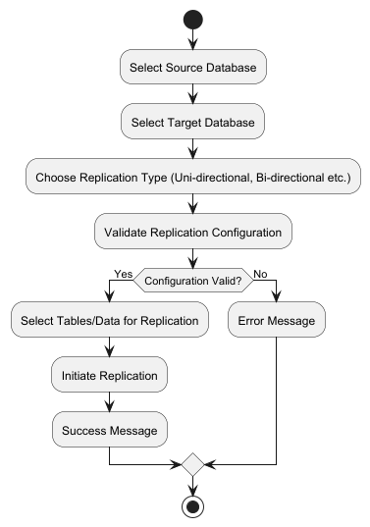
Figure 25 - Activity Diagram – Adding a Replication Strategy.
Sequence Diagram – Adding a Replication Strategy.
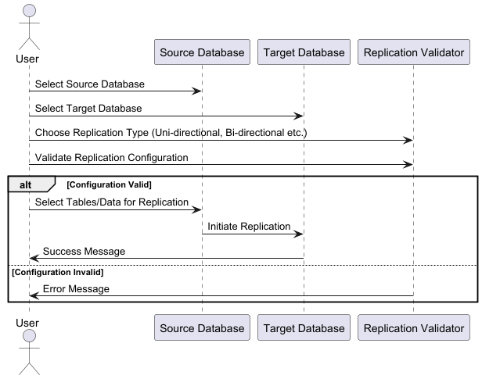
Figure 26 - Sequence Diagram – Adding a Replication Strategy.

5.2.4 Adding a Consistency Strategy.

Use Case Name | Add A Consistency Strategy to the Database
Use Case Id | 03
Context of Use | Database Admin wants to enforce a consistency strategy on database.
Scope | System - Database Consistency
Priority | Must Have
Source | Requirements
Primary Actor | DBA
Other Participating Actors | N/A
Description | DBA wants to enforce a database consistency strategy onto the database to improve data validity.
Preconditions | Database must be added to the system already.
Success End Conditions | Consistency Strategy is applied to database.
Failed End Conditions | No strategy is applied to database.
Trigger | DBA clicks Add Consistency Strategy.
Expected Scenario | DBA | System
 | Step 1:  DBA clicks edit configuration on database.  Step 3:  DBA clicks add Consistency Strategy.  Step 5:  DBA clicks choice of consistency strategy.  Step 7:  DBA fills in and selects optional configuration details. | Step 2:  System displays database Configuration UI.  Step 4:  System displays choice of consistency strategy for Database type.  Step 6:  System displays optional details for the configuration.  Step 8:  System attempts to apply Strategy to the database.  Step 9:  System determines successful application of strategy.  Step 10:  Details of Strategy saved to system. And success message displayed.
Alternate Scenarios | DBA | System
Alternative 1  Database Consistency Strategy already exits. | Step 3:  DBA clicks add Consistency Strategy.  Step 6:  DBA clicks remove previous strategy. | Step 4:  System detects Consistency strategy already on Database.  Step 5:  System displays choice of Removal of previous strategy.  Step 7:  System removes previous strategy from the database.  Step 8:  System displays removal success notification. Returns to step 2 of ideal path.
Alternative 2  Database Consistency strategy unable to be applied to Database. |  | Step 9:  System determines Strategy configuration unable to be applied to Database.  Step 10:  System rolls back attempted changes.  Step 11:  System Displays error message.  Returns to step 6 of ideal path.
Conclusions | Consistency strategy applied to database.
Post conditions | N/a
Business Rules | N/a
Implementation Constraints | N/a

Activity Diagram – Adding a Consistency Strategy.
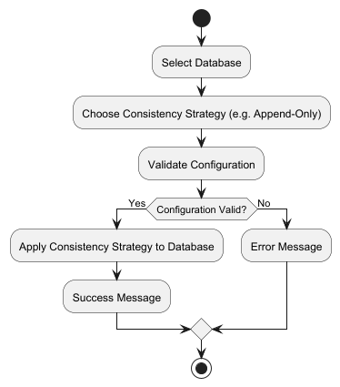
Figure 27 - Activity Diagram – Adding a Consistency Strategy.
Sequence Diagram – Adding a Consistency Strategy.
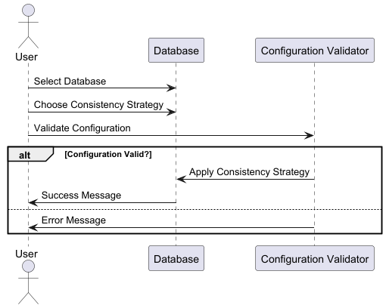
Figure 28 - Sequence Diagram – Adding a Consistency Strategy.

5.2.5 Adding a Replication Sync Checker.

Use Case Name | Add a Replication Sync Checker
Use Case Id | 05
Context of Use | Database Admin, wants to ensure that the replication is consistent.
Scope | System - Database Replication
Priority | Must Have
Source | Requirements.
Primary Actor | DBA
Other Participating Actors | N/a
Description | A replication strategy was applied to two databases, The sync checker will determine the health of the data transfer between these two databases.
Preconditions | Replication strategy applied to two databases.
Success End Conditions | Sync Checking applied to the replication strategy
Failed End Conditions | Sync Checker failed to be created.
Trigger | DBA creates Replication strategy successfully.
Expected Scenario | DBA | System
 | Step 1:  DBA Created replication strategy or clicks add sync check to a replication strategy.  Step 4:  DBA selects time interval and fills in configuration details. | Step 2:  System Retrieves details of replication strategy.  Step 3:  System displays sync check configuration UI  Step 5:  System checks valid configuration.  Step 6:  System creates sync checker.  Step 7:  On selected Time Period compare source and target database data.  Step 8:  System finds no data discrepancies.  Generates success report.  etc
Alternate Scenarios | DBA | System
Alternative 1 –  System Finds Discrepancies. |  | Step 8:  System finds data discrepancies.  Step 9:  System Identifies discrepancy details.  Step 10:  Generate Discrepancy report.  Step 11:  System notifies admin.
Alternative 2 –  Sync Checker Details invalid |  | Step 5:  System finds configuration invalid.  Step 6:  System displays appropriate error message. Returns to step 3.
Conclusions | Sync Checking for replication strategy has been created.
Post conditions | N/a
Business Rules | Replication between databases must be checked, if data discrepancies found notify administration.
Implementation Constraints | N/a

Activity diagram – Adding a Replication Sync Checker.
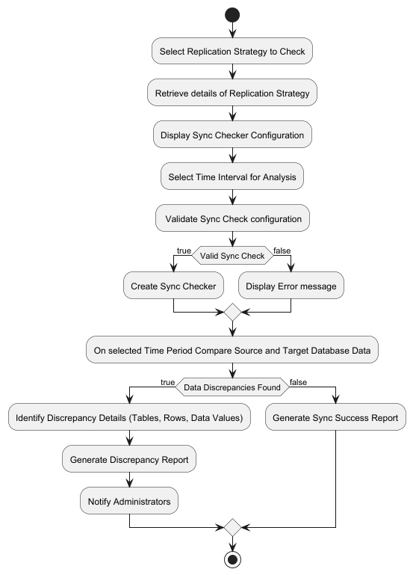
Figure 29 - Activity diagram – Adding a Replication Sync Checker.

Sequence Diagram – Adding a Replication Sync Checker.
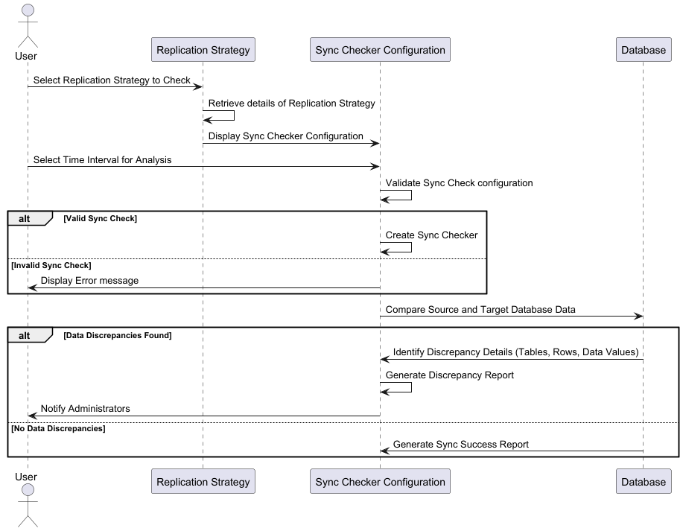
Figure 30 - Sequence Diagram – Adding a Replication Sync Checker.

5.3 UML Class Diagram.
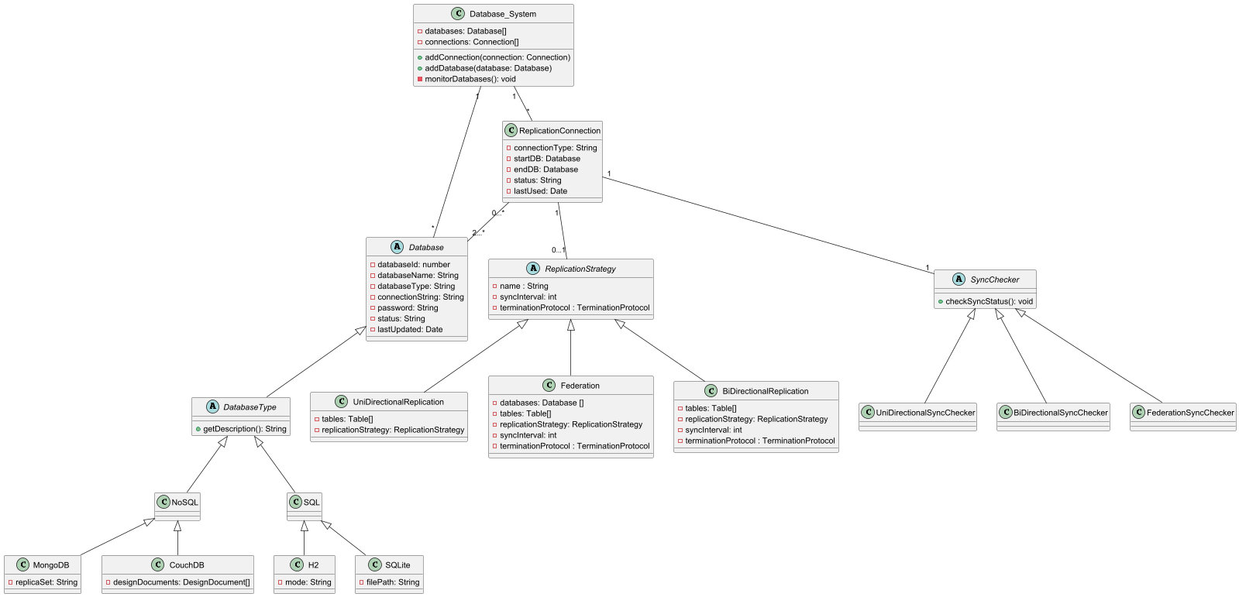
Figure 31 - Project UML Class Diagram
While the UML Class diagram is currently incomplete it allows for the insight into possible injections of Software Design patterns.
Particularly around the incorporation of the Builder or Factory patterns when creating the Replication Connections and the Database objects. These patterns would streamline the instantiation of these complex objects, enhancing code maintainability and flexibility.
The UML diagram clearly demonstrates the central role of composition and aggregation in structuring the project's object relationships, which will be crucial for achieving the desired system architecture and functionality.
The use of the Strategy Design Pattern could be implemented for the Replication Strategy class and possibly even the Sync Checker Class, implementing a different strategy based on the underlying replication strategy.

5.4 Draft Sprints in Jira.
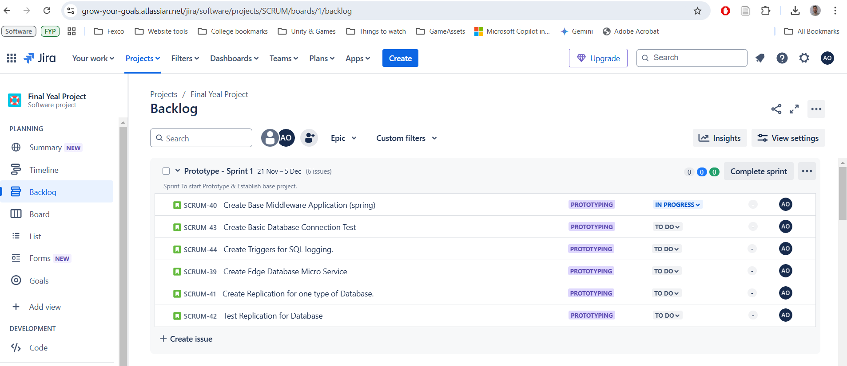
Figure 32 - Jira Backlog Sprint 1 - Prototype
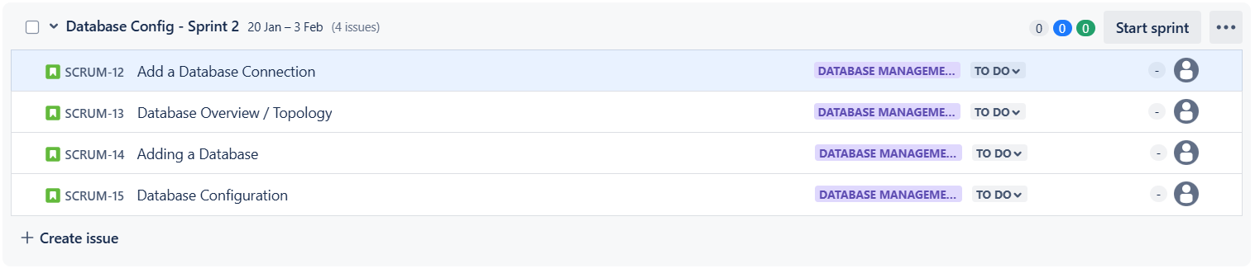
Figure 33 - Jira Backlog Sprint 2 – Database Configuration
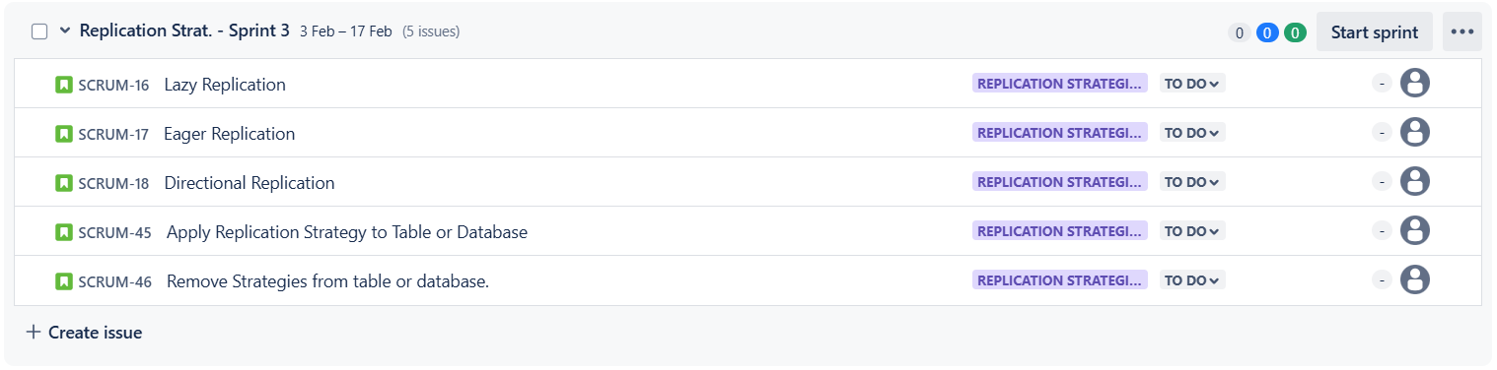
Figure 34 - Jira Backlog Sprint 3 – Replication Strategies
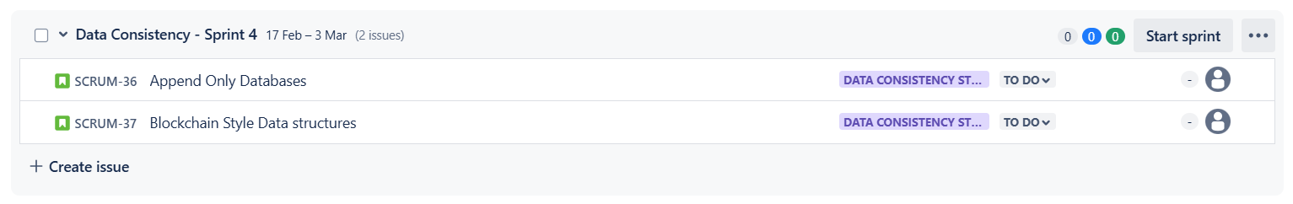
Figure 35 - Jira Backlog Sprint 4 – Database Consistency
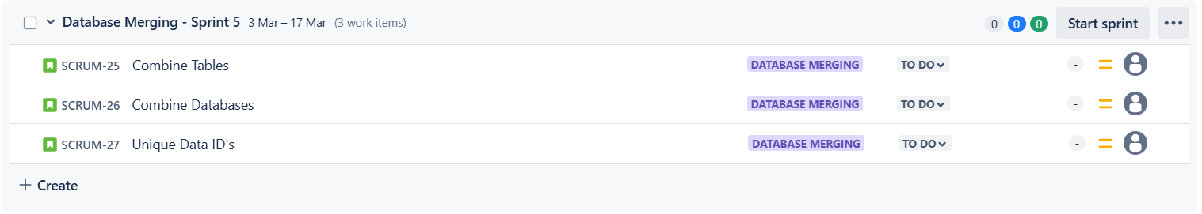
Figure 36 - Jira Backlog Sprint 5 – Database Merging.
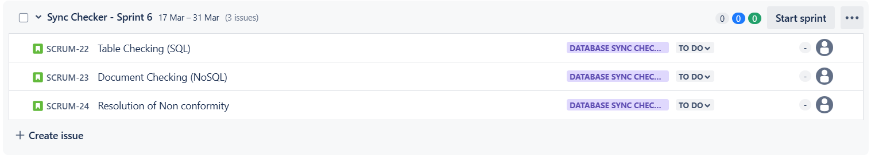
Figure 37 - Jira Backlog Sprint 6 – Database Sync Checking
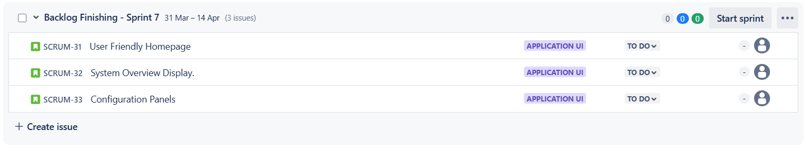
Figure 38 - Jira Backlog Sprint 7 – Backlog Finish
Remaining Backlog Items (Not assigned to sprints)
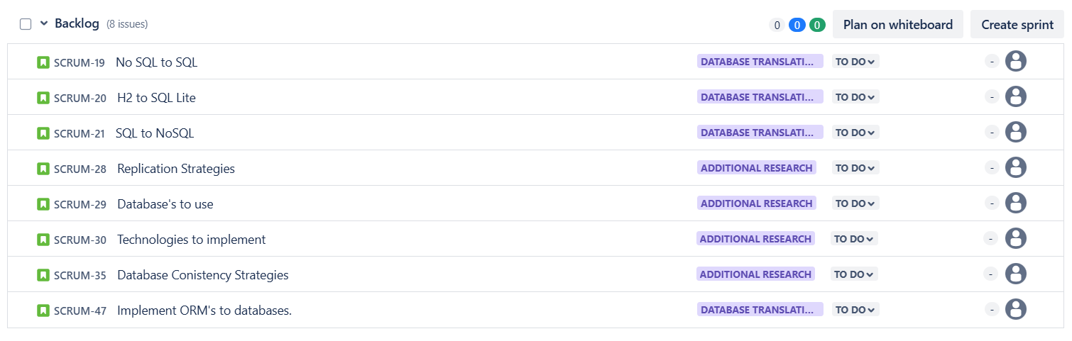
Figure 39 - Jira Backlog - Remaining Items

5.5 Reflection on the Design Documentation Process.
The initial Activity and Sequence diagrams were created based upon the Jira User Stories, the user stories while being a valuable resource show a higher level of functionality of the system.
Grouping the user stories into their respective Epics on Jira also yields a great relationship between the functional requirements and the user stories. This link helps to direct the overall system architecture during the implementation phase.
While the activity and sequence diagrams produced from the User Stories provided a visual representation of the system's intended behaviour, the development of detailed use case scenarios uncovered limitations in the initial diagrams.
Translating the visual models into textual use cases, which describe specific user interactions and system responses, forced a deeper consideration of the system's functionality.
This more granular perspective revealed gaps and ambiguities in the original diagrams, necessitating revisions to ensure alignment between the visual models and the detailed use case descriptions.
This iterative refinement process ultimately strengthened the overall design and ensured a more complete understanding of the system's requirements. The use of PlantUML significantly facilitated this iterative design process.
PlantUML’s text-based diagramming approach allowed for rapid creation and modification of both activity and sequence diagrams, simplifying the process of revising and refining the visual models.
The ability to quickly generate and update diagrams based on textual descriptions streamlined the synchronization between the diagrams and the evolving use case scenarios.
This tight integration between textual descriptions and visual representations, enabled by PlantUML, fosters a more agile and responsive design process, ensuring consistency and clarity throughout the project's evolution.

5.6 Testing Strategies.
The testing strategy for the DDBMS project will encompass both static and dynamic testing methodologies.
Static testing, utilizing SonarCloud (Sonar, 2024) integration, will be performed continuously throughout the development process to ensure code quality, adherence to clean code principles, and early detection of potential bugs and vulnerabilities. This will involve analysing code complexity, adherence to coding standards, and potential security risks.
Test-Driven Development (TDD) will be employed, with unit tests created before the implementation of each feature. This approach will ensure high test coverage and help maintain code functionality as the project evolves.
The TDD methodology will ensure that testability is incorporated into the design and development process which promotes modular and maintainable code.
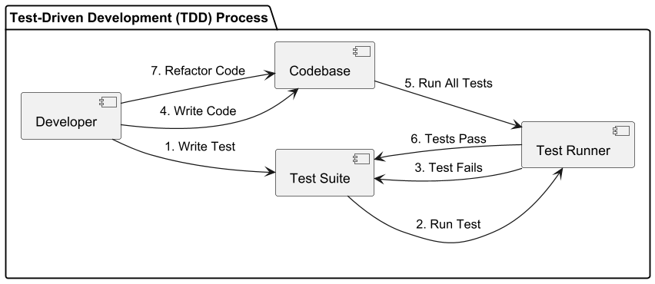
Figure 40 - Overview of the TDD Approach
Dynamic testing, using JMeter (Apache JMeter, 2024), will focus on performance and consistency validation of the DDBMS under simulated load conditions.
Various scenarios, including high-volume write operations, will be simulated to evaluate the system's ability to handle realistic workloads.
Performance metrics such as data transfer latency between replicated databases, throughput, and resource utilization will be collected and analysed.
The integrated synchronization checker will play a crucial role in validating data consistency across replicas during these load tests, verifying the effectiveness of the implemented consistency strategies.
End-to-end (E2E) testing, employing a framework like Cypress.io (Cypress.io, 2024), will be crucial for validating the complete functionality of the DDBMS and its integrated components.
These tests will simulate real-world user interactions with the GUI and the DDBMS middleware is functioning as specified in the user stories and use cases, creating a simulated walkthrough of the system.
To test Eventual Consistency with the replication nodes, a delay between the replicas will need to be configurable. In order to sufficiently test that writes to the same tables at different replicas are correctly propagated throughout the system.
This will require extensive testing to ensure adequate confidence in the system consistency, as the issue with eventually consistent systems is that 99% of the time conflicts do not arise and only when the system is in production do these issues crop up as seen in the case study during work placement.
This comprehensive testing approach aims to ensure the robustness, reliability, and performance of the DDBMS under various operational conditions.

Chapter 6: Prototype.

6.1 Why the Spring Framework.
The Spring Framework offers several advantages relevant to building the proposed DDBMS with configurable replication and consistency as described.
Firstly, Spring simplifies the development of microservices, which aligns with the project's goal of managing replication in a microservice architecture.
Its auto-configuration and embedded server capabilities streamline the creation and deployment of individual microservices responsible for specific aspects of the DDBMS, such as managing replication for a particular database type or implementing a specific consistency protocol.
Additionally, Spring's robust support for RESTful APIs facilitates communication between these microservices, allowing them to coordinate replication tasks and exchange data efficiently.
Secondly, Spring's extensive ecosystem, including projects like Spring Data, provides valuable tools for integrating with various databases. Spring Data simplifies database interactions, supporting both relational and NoSQL databases, which is crucial for the project's heterogeneous database support requirement.
Building upon this, the Spring framework fosters a large and active community, providing extensive documentation, tutorials, and support forums. This vibrant community ensures access to a wide range of expertise and readily available solutions to common challenges.

6.2 Creating the Database Management Middleware.
As discussed above the middleware framework used is the Spring Framework, to start a spring project it is advised to use spring initializer commonly known as Spring Boot. This can be found at start.spring.io (Spring.io, 2024b) the resulting interface will look as follows.
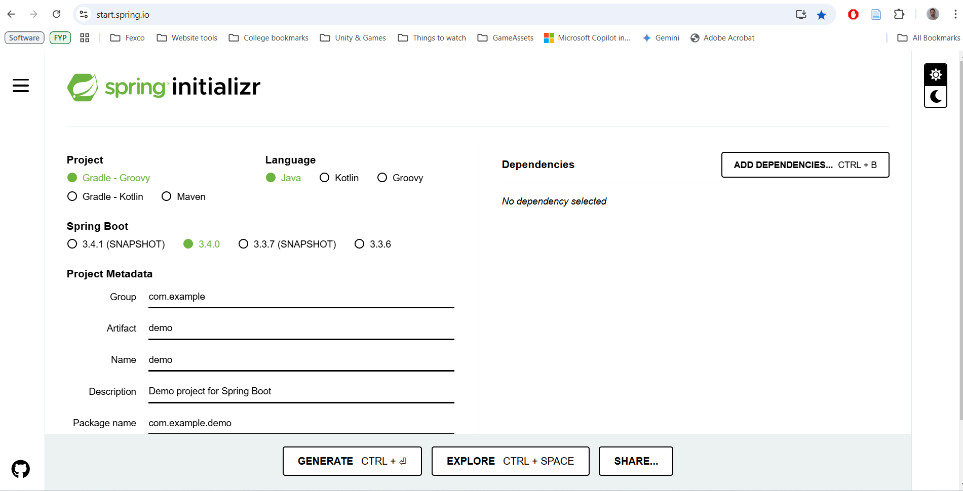
Figure 41 - Creating a base Spring package using Spring Initialiser
Spring can be used in either Java, Kotlin or the Groovy programming languages, it also allows for the choice of build tools. For the middleware prototype, the choice of Java Language and Maven build tooling was chosen due to a familiarity with the software from previous projects and experiences.
Dependencies can be added at any time to the pom.xml file, however, with spring initializer you can begin the project with some of the most used dependencies.
This prototype will add the dependencies of Lombok (projectlombok.org, 2024), Spring Data JPA (Spring.io, 2024a), Spring Web and H2 Database (h2database.com, 2024) as shown in the example below.
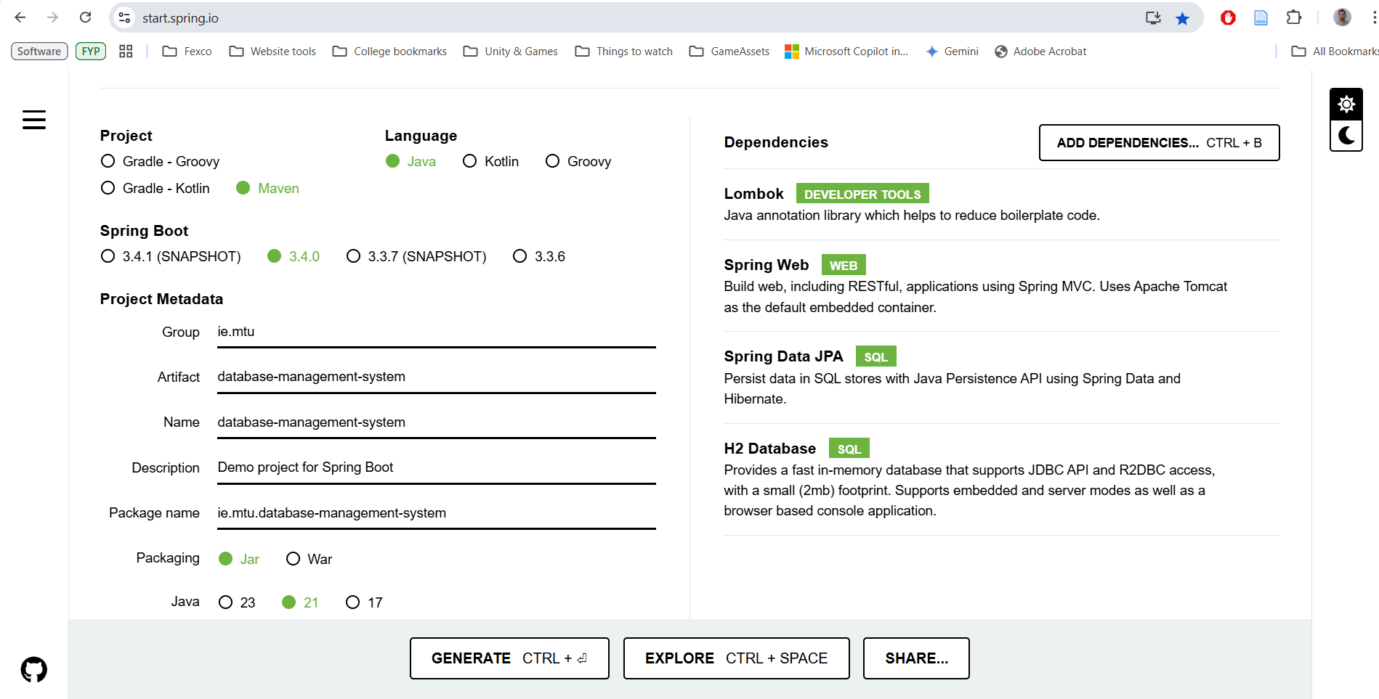
Figure 42 - Adding Dependencies with Spring Initialiser.
Clicking Generate will provide a base .zip file containing all the base project requirements and the dependencies added in the pom.xml file.
Once the zip file has been extracted and placed into a chosen IDE, of which IntelliJ IDEA was chosen due to its ease of use and extensive plugin and language support, the project can begin to take shape.
With Spring applications it is common practice to begin splitting the folder structure and base architecture into Controllers which provide the API end points and act as a outer façade pattern to the project, Services which contain the logic and methods of the system and can be called by the respective controllers, Entities which act as the data objects of the system for saving data and object creation, and Repositories which define the way to store the entities in a respective database.
This structure can be seen on the following screenshot of the prototype’s development in IntelliJ:
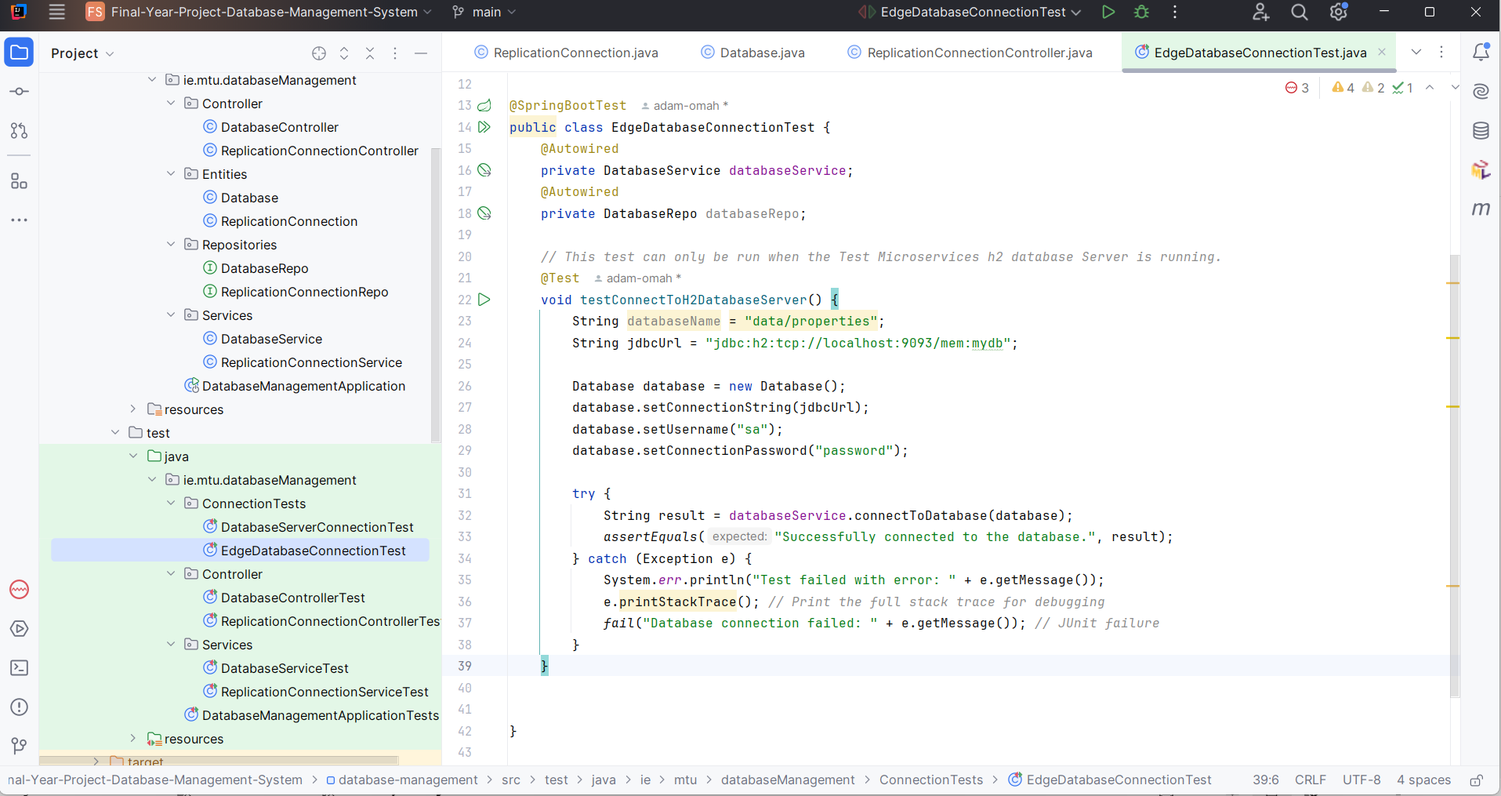
Figure 43 - Project Folder Structure and Unit Tests
Unit tests are employed in the prototype to test the functionality of the controller and service classes, this followed the comprehensive testing approach defined in chapter 5, the unit tests can be seen in the above screen shot using the JUnit testing suite (junit.org, 2024).

6.3 Creating the Test for Edge Database Connection.
Once the base middleware services and controllers were created, the need to test the system with an extended microservice became the next focus.
Using a microservice which contained a H2 edge database that had been previously developed for the Software Design Patterns module as a basis for testing purposes was an ideal choice for the proposed prototype.
This microservice also used the Spring framework and contained a sample API of a Properties Service which was responsible for creating and managing Properties and their respective Owners.
The functionality of the microservice is not a necessary consideration for the purpose of the project, the fact that there is a simple Create, Read, Update and Delete (CRUD) functionality is all that is required.
A simple test to connect to this edge database was created with the H2 database end point as the connection string, the username and password used are associated with the edge database on this service.
To run the test the microservice needs to be running so as to simulate the real use case of connecting the middleware to a live microservice.
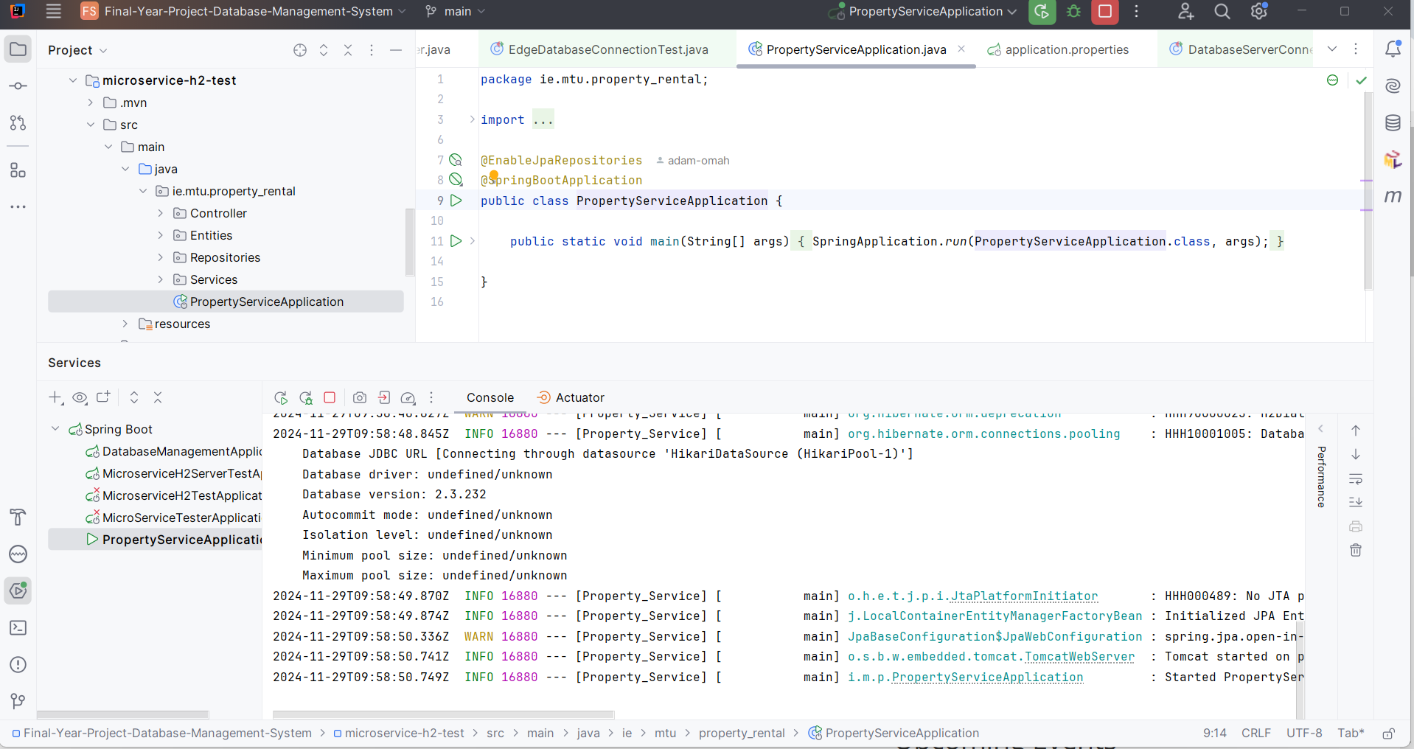
Figure 44 – Microservice application running prior to test runs.
After the service has fully launched, approximately 10 seconds later, the tests for the connection of the database middleware can be run.
The Spring framework comes equipped with the @SpringBootTest annotation which is a decorator that enables the tests to boot the application once before the tests are run and proceed with the testing process with the base spring application running.
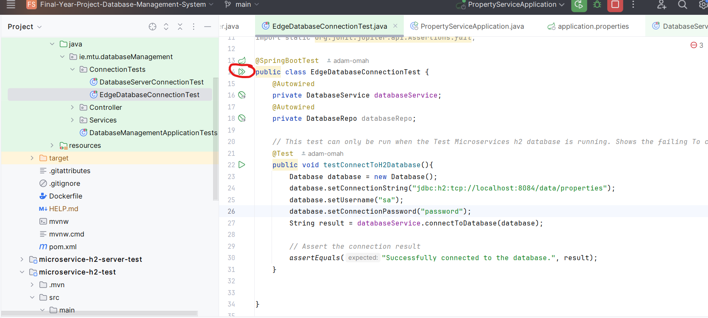
Figure 45 - Spring JUnit Testing
Initiating the test is achieved by clicking on the double arrow icon shown above.
The following screenshot shows the @SpringBootTest annotation in action:
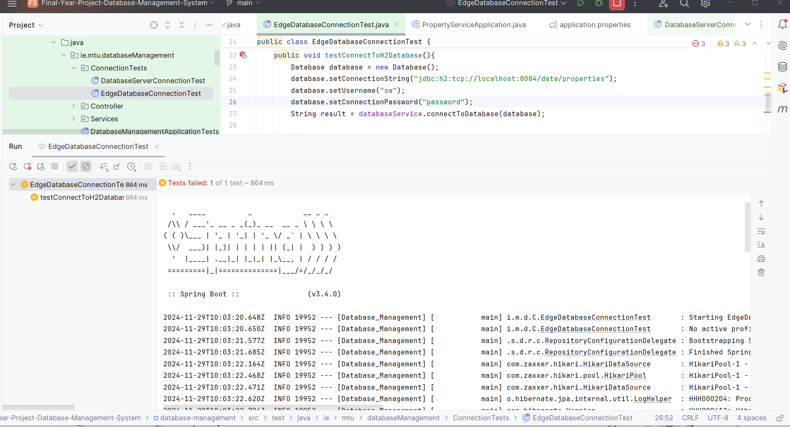
Figure 46 - @SpringBootTest annotation in action
The tests then become a sub-unit of the spring boot application, as shown above the testConnectToH2Database test is a child of the overall test suite.
Checking the results of this test failure, shown below, starts to provide a clear insight and possible failure point of the entire Project proposal.
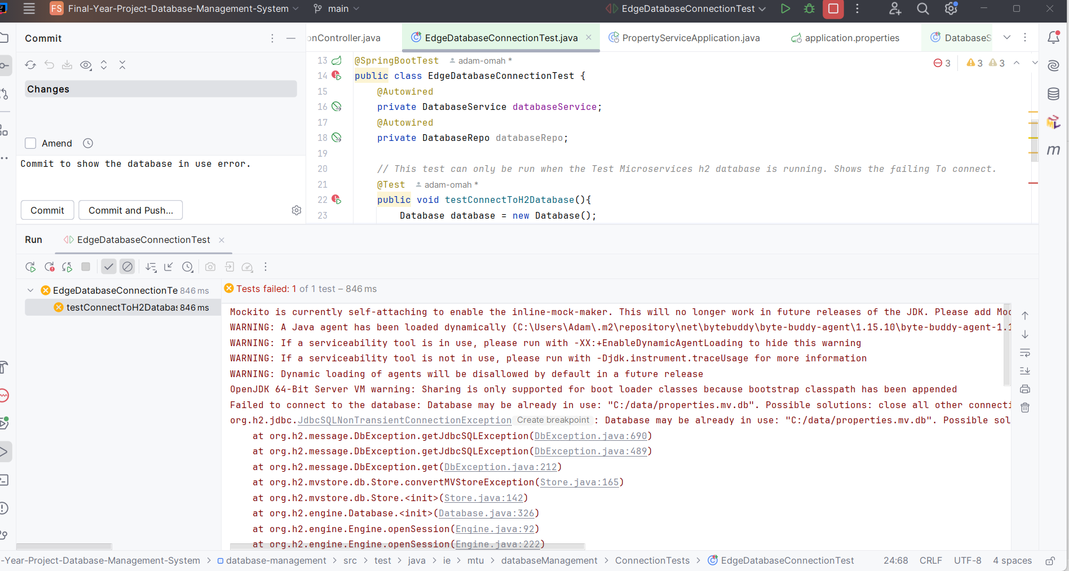
Figure 47 - Spring Error message for Edge Database.
The error message that is most useful in the above is the following:
Failed to connect to the database: Database may be already in use: “C:/data/properties.mv.db”. Possible solutions: close all other connection(s); use the server mode.
Delving further into the root cause of this connection issue, it was discovered that this is a key part of many edge databases.
Their goal of being lightweight and providing data as close to the source as possible means that many edge databases do not allow a direct connection via the Java Database Connectivity (JDBC) connector (Oracle, 2024), even if they implement the JDBC library such as within the H2 database.

6.3 Creating the Test for Server Database Connection.
From the previous test it was shown that the possibility of connection to an edge database directly may not be possible.
However, from the error shown by the system, there should be no issue with connecting to a H2 database in server mode.
As such a copy of the microservice was created at this point to test this hypothesis, in the prototype repository it is labelled as microservice-h2-server-test.
This module is the same as the previous microservice, with the key difference of an additional configuration for the H2 server, this is found in the configuration folder and named H2ServerConfiguration as shown in the following screenshot.
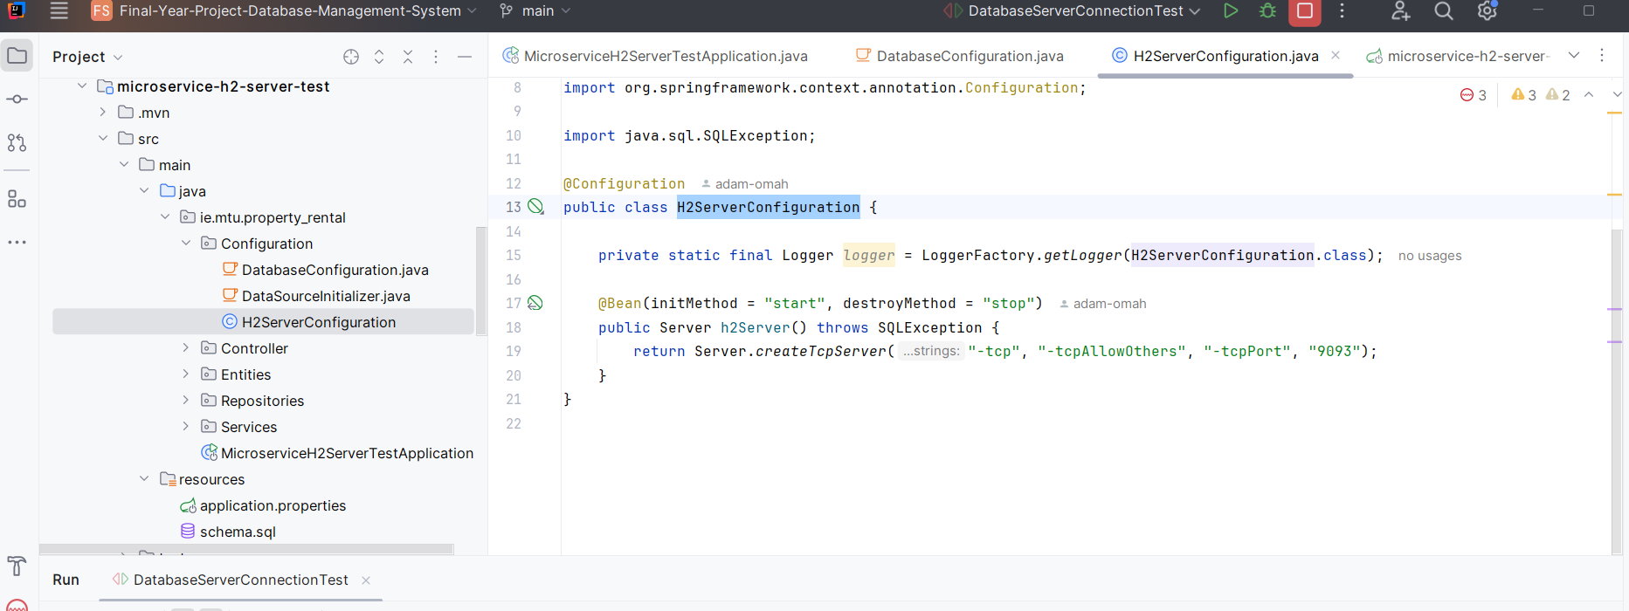
Figure 48 - H2 Server mode configuration
This code creates an external Transmission Control Protocol (TCP) connection at the port 9093, essentially turning the H2 database into a server.
The test for the connection to this database is slightly different from the previous connection test as now the connection string must point to the TCP connection, this test is shown below.
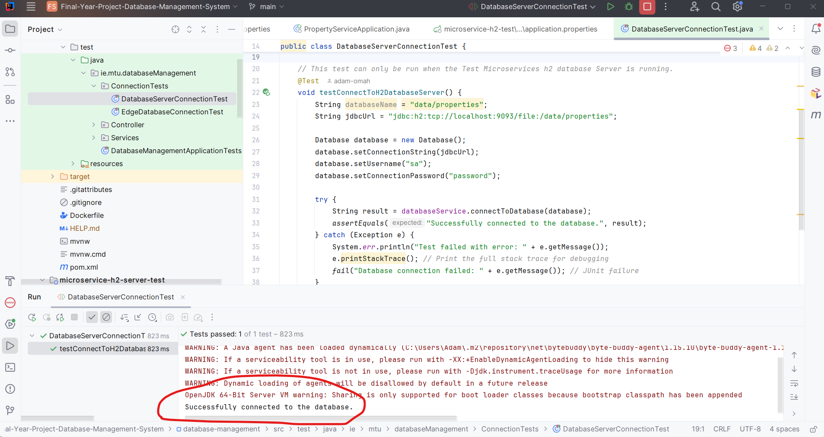
Figure 49 - H2 Server successful connection from Middleware
This screenshot also shows the successful connection of the middleware to the H2 database in server mode.

6.4 Findings and Results of Prototype.
The prototype development and testing phase yielded significant findings regarding the feasibility and challenges of the proposed DDBMS architecture.
GitHub Repository Link for Prototype:
https://github.com/adam-omah/Final-Year-Project-Database-Management-System
Successful connection to an H2 database operating in server mode demonstrated the potential for managing replicated data if the database has the potential allow external connections.
However, the inability to directly connect to an embedded H2 database, typical in many edge deployments, highlighted a critical limitation.
This necessitates a shift in the architectural approach, requiring edge databases to either transmit data via a log messaging system for ingestion by the DDBMS or be configured with external server connection points.
The latter presents a significant challenge due to the varied nature of edge databases and the lack of a universally applicable server mode implementation, as readily available with H2.
These findings suggest that further investigation into alternative integration strategies, such as database plugins or exploring database-specific replication mechanisms, may be necessary for a fully realized DDBMS solution capable of managing diverse microservice deployments.
Thus, it was decided to end the prototype development at this point rather than delve into the remaining prototype tasks of SQL Triggers for queries to enable logging and replication of the databases as previously suggested in the project plan.
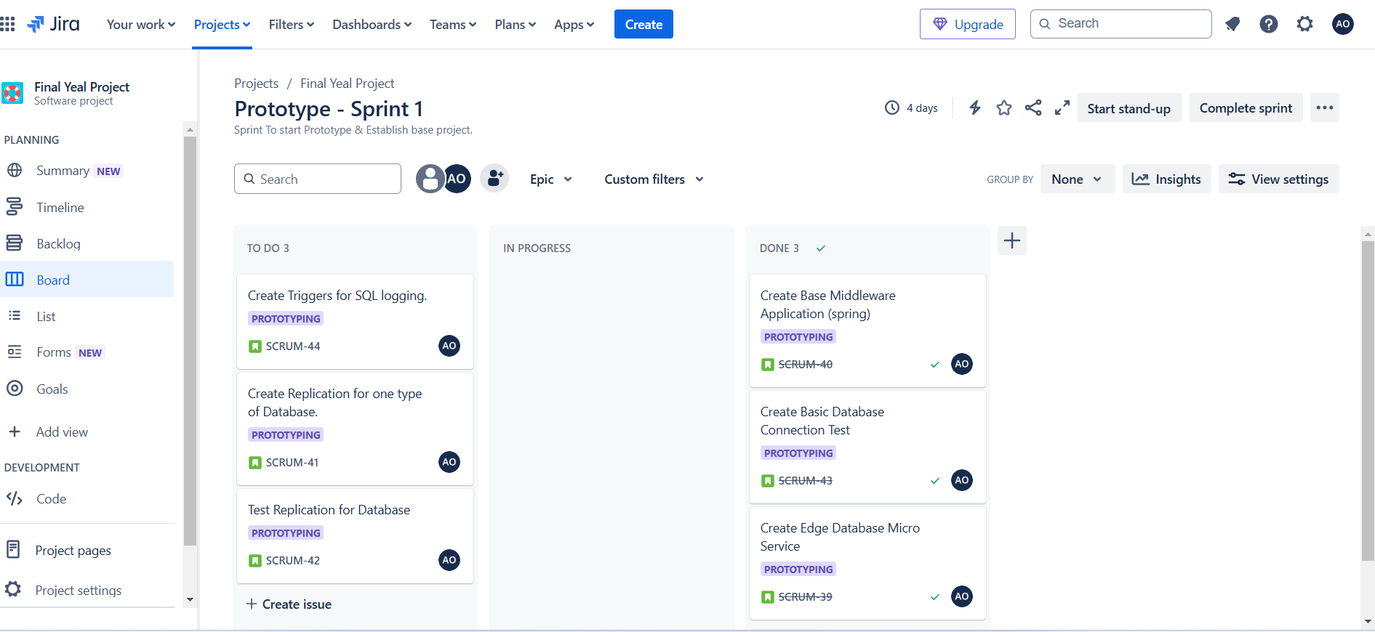
Figure 50 - Jira Board at end of sprint - Ended Tuesday 26th November2024 due to findings.

Chapter 7: Proposed Pivot of Database Management System.

7.1 What can still be used based on the research, design, methodology and project plan.
As the prototype has shown key failure points and brings into question the validity of a one fits all solution for data consistency and replication of databases in the distributed environment of the microservices architecture, it is paramount to the success of the development of the project to re-evaluate what can still be achieved in this realm based on the problems the project intended to solve.
Given the evidence that there is a clear need for data consistency within the distributed environment, the use of data consistency strategies provides a key functional requirement going forward.
The ability for the microservices database to be replicated to improve fault tolerance and availability is again a key functional requirement.
In fact, the majority of the research will still be applicable, however, the project itself is what will change the most.
The key pivot will be rather than attempting to create a generic Database Management Middleware, the focus will be more on creating a data consistent database system.
The testing strategies outlined will also be applicable to the new project as these core ideas will still be fundamentally the same in terms of testing.

7.2 Database Engine or Wrapper that promotes data consistency and replication using Immutable Data strategies.
This revised project proposed will be an immutable database system with master-master replication, enabling writes to any node for enhanced performance and availability in microservices.
This approach offers significant advantages, immutability ensures strong data consistency and simplifies concurrency control, while master-master replication would provide high availability and fault tolerance, distributing the load across multiple nodes.
The proposed solution will focus on the trade-offs associated with using the Master-Master replication methodology, Asynchronous data propagation, and high data consistency due to the restriction of immutability.
Two implementation strategies are considered, developing a new database engine optimized for immutability and replication, or creating a database wrapper around an existing engine like H2 or SQLite.
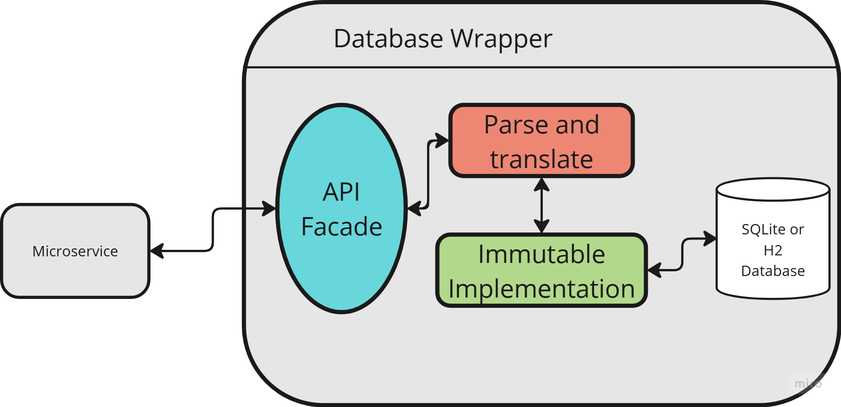
Figure 51 - Example of Database Wrapper
A middleware layer is also being considered, similar to ZooKeeper in Hadoop, simplifies management of the distributed immutable database.(GeeksforGeeks, 2022)
It could be used to ensure data consistency via a sync checker and possibly facilitate functions like replication management and load balancing.
This abstraction simplifies deployment and monitoring, potentially offering a user-friendly experience akin to CouchDB's Fauxton interface.
Thus, a full re-write of the Jira User stories, Use Cases, Activity & Sequence diagrams as well as an updated system UML diagram will need to be undertaken prior to the initiation of the revised project.

Conclusion.
This research has explored the multifaceted challenges of database management within the microservices architecture.
While the theoretical benefits of microservices, such as independent deployment and scalability, are undeniable, the distributed nature of these systems introduces significant complexities in ensuring data consistency, managing network partitions, and maintaining overall performance.
The investigation revealed a disconnect between the idealized notion of a dedicated database per microservice and the practical realities of implementation, often necessitating compromises like shared databases or API composition, each with inherent trade-offs.
The exploration of various database strategies, coupled with the analysis of technologies like ORMs, CDC, Edge Databases, blockchain, and immutable databases highlighted the ongoing efforts to address data consistency and replication challenges in distributed database environments.
The case study of a real-world eventual consistency issue served as a stark reminder of the practical implications of these challenges.
The difficulty in identifying and resolving the intermittent data corruption underscored the limitations of relying solely on eventual consistency in certain scenarios and emphasized the need for more robust consistency mechanisms in distributed systems, particularly those operating with financial data or sensitive information.
This incident highlighted the importance of rigorous testing and careful consideration of consistency models when designing microservice architectures.
The research also underscored the critical role of organizational and cultural factors in successfully implementing and managing data within microservices.
Clear data governance policies, robust documentation, knowledge sharing, and a collaborative culture are essential for navigating the complexities of decentralized data management.
The shift towards microservices requires not only a technological transformation but also a shift in mindset and organizational practices as shown by Spotify’s example for the drive toward developer understanding. While not investigated in this paper, their use of sharing developer knowledge with the use of their Backstage (Spotify, 2024) opensource platform really shows their dedication to placing the developers needs first.
Finally, the proposed Distributed Database Management System (DDBMS), though challenged by the limitations revealed in the prototype phase, offers a potential pathway towards a more flexible and manageable approach to microservice database management.
The pivot towards an immutable database system with master-master replication, utilizing the restriction of data immutability and logical consistency checks, holds promise for addressing the core challenges of data consistency, availability, and performance.
Future research and development efforts could focus on refining these strategies and exploring alternative integration mechanisms, such as leveraging contract-first message queues or database-specific replication techniques.
As fundamentally the approach to databases and microservices in a distributed environment becomes a balancing act of what trade-offs and advantages are best leveraged for a specific use case.

References & Bibliography

References:

Apache JMeter, 2024. Apache JMeter - Apache JMeterTM. [online] Available at: <https://jmeter.apache.org/> [Accessed 3 December 2024].
apache.org, 2024. Apache Kafka. [online] Apache Kafka. Available at: <https://kafka.apache.org/> [Accessed 30 November 2024].
Baran, E., 2024. How to address decentralized data management in microservices. [online] Cerbos. Available at: <https://cerbos.dev/blog/data-management-in-microservices> [Accessed 21 November 2024].
Cecchet, E., Candea, G. and Ailamaki, A., 2008. Middleware-based database replication: the gaps between theory and practice. In: Proceedings of the 2008 ACM SIGMOD international conference on Management of data, SIGMOD ’08. [online] New York, NY, USA: Association for Computing Machinery. pp.739–752. Available at: <https://dl-acm-org.mtu.idm.oclc.org/doi/abs/10.1145/1376616.1376691> [Accessed 19 September 2024].
Chopra, R., 2017. Cloud Computing: An Introduction. [online] Bloomfield, UNITED STATES: Mercury Learning & Information. Available at: <http://ebookcentral.proquest.com/lib/munster/detail.action?docID=4895092> [Accessed 11 October 2024].
Connolly, T. and Begg, C., 2014. Database Systems: a Practical Approach to Design, Implementation, and Management, Global Edition. [online] Harlow, UNITED KINGDOM: Pearson Education, Limited. Available at: <http://ebookcentral.proquest.com/lib/munster/detail.action?docID=5174902> [Accessed 11 October 2024].
Coulouris, G., Dollimore, J., Kindberg, T. and Blair, G., 2011. Distributed Systems: International Edition. [online] Harlow, UNITED KINGDOM: Pearson Education, Limited. Available at: <http://ebookcentral.proquest.com/lib/munster/detail.action?docID=5176822> [Accessed 18 October 2024].
Cypress.io, 2024. Testing Frameworks for Javascript | Write, Run, Debug | Cypress. [online] Available at: <https://www.cypress.io/> [Accessed 3 December 2024].
Daraghmi, E., Cheng-Pu, Z. and Yuan, S.-M., 2022. Enhancing Saga Pattern for Distributed Transactions within a Microservices Architecture. Applied Sciences, [online] 12(12), p.6242. <https://doi.org/10.3390/app12126242> [Accessed 5 December 2024].
Debezium.io, 2024. Debezium. [online] Debezium. Available at: <https://debezium.io/> [Accessed 30 November 2024].
Dhulavvagol, P.M., Totad, S.G. and Bhandage, N., 2022. Topic Based Partitioning for Selective Search Using Sharding Technique. In: 2022 International Conference for Advancement in Technology (ICONAT). [online] 2022 International Conference for Advancement in Technology (ICONAT). pp.1–5. Available at: <https://ieeexplore-ieee-org.mtu.idm.oclc.org/document/9726020> [Accessed 18 October 2024].
Fowler, M., 2024. Microservice Trade-Offs. [online] martinfowler.com. Available at: <https://martinfowler.com/articles/microservice-trade-offs.html> [Accessed 25 November 2024].
Furda, A., Fidge, C., Zimmermann, O., Kelly, W. and Barros, A., 2018. Migrating Enterprise Legacy Source Code to Microservices: On Multitenancy, Statefulness, and Data Consistency. IEEE Software, [online] 35(3), pp.63–72. <https://doi.org/10.1109/MS.2017.440134612> [Accessed 22 November 2024].
GeeksforGeeks, 2022. What is Apache ZooKeeper? [online] GeeksforGeeks. Available at: <https://www.geeksforgeeks.org/what-is-apache-zookeeper/> [Accessed 1 December 2024].
Georgiou, M.A., Panayiotou, M., Odysseos, L., Paphitis, A., Sirivianos, M. and Herodotou, H., 2021. Attaining Workload Scalability and Strong Consistency for Replicated Databases with Hihooi. In: Proceedings of the 2021 International Conference on Management of Data. [online] SIGMOD/PODS ’21: International Conference on Management of Data. Virtual Event China: ACM. pp.2721–2725. Available at: <https://dl.acm.org/doi/10.1145/3448016.3452746> [Accessed 30 September 2024].
Gordon, J., 2024. Optimizing for Fast, Responsive Reads with Cross-Region Replication in MongoDB Atlas | MongoDB Blog. [online] MongoDB. Available at: <https://www.mongodb.com/blog/post/optimizing-fast-responsive-reads-cross-region-replication-mongodb-atlas> [Accessed 2 December 2024].
Gu, Y., Wang, X., Shen, S., Ji, S. and Wang, J., 2015. Analysis of data replication mechanism in NoSQL database MongoDB. In: 2015 IEEE International Conference on Consumer Electronics - Taiwan. [online] 2015 IEEE International Conference on Consumer Electronics - Taiwan. pp.66–67. Available at: <https://ieeexplore.ieee.org/document/7217033/?arnumber=7217033> [Accessed 2 December 2024].
h2database.com, 2024. H2 Database Engine. [online] Available at: <https://www.h2database.com/html/main.html> [Accessed 29 November 2024].
Helland, P., 2012. Idempotence Is Not a Medical Condition: An essential property for reliable systems. Queue, [online] 10(4), pp.30–46. <https://doi.org/10.1145/2181796.2187821> [Accessed 11 November 2024].
Helland, P., 2015. Immutability Changes Everything: We need it, we can afford it, and the time is now. Queue, [online] 13(9), pp.101–125. <https://doi.org/10.1145/2857274.2884038> [Accessed 11 November 2024].
ImmuDB, 2024. immudb - The lightweight, high-speed immutable database. [online] immudb. Available at: <https://immudb.io> [Accessed 3 December 2024].
JBS Dev, 2024. Microservices: The Good, the Bad, and the Better. [online] Available at: <https://www.jbs.dev/resources/resource-center/whitepapers/microservices-good-bad-and-better/> [Accessed 29 November 2024].
junit.org, 2024. JUnit 5. [online] Available at: <https://junit.org/junit5/> [Accessed 29 November 2024].
Kaloudis, M., 2024. Evolving Software Architectures from Monolithic Systems to Resilient Microservices: Best Practices, Challenges and Future Trends. International Journal of Advanced Computer Science and Applications, [online] 15(9). <https://doi.org/10.14569/IJACSA.2024.0150901> [Accessed 30 November 2024].
Kent Beck et al., 2024. Manifesto for Agile Software Development. [online] Available at: <https://agilemanifesto.org/> [Accessed 7 November 2024].
Kong, C., Gao, M., Qian, W., Zhou, M., Gong, X., Zhang, R. and Zhou, A., 2015. ACID Encountering the CAP Theorem: Two Bank Case Studies. In: 2015 12th Web Information System and Application Conference (WISA). [online] 2015 12th Web Information System and Application Conference (WISA). pp.235–240. Available at: <https://ieeexplore-ieee-org.mtu.idm.oclc.org/document/7396642> [Accessed 18 October 2024].
M. Wiesmann, F. Pedone, A. Schiper, B. Kemme, and G. Alonso, 2000. Database replication techniques: a three parameter classification. Proceedings 19th IEEE Symposium on Reliable Distributed Systems SRDS-2000, [online] pp.206–215. <https://doi.org/10.1109/RELDI.2000.885408>.
Mapanga, I. and Kadebu, P., 2013. Database Management Systems: A NoSQL Analysis. Database Management Systems, [online] 1(7). Available at: <https://media.neliti.com/media/publications/265849-database-management-systems-a-nosql-anal-b2ed9f93.pdf> [Accessed 18 October 2024].
MongoDB, 2024. What Is Replication In MongoDB? [online] MongoDB. Available at: <https://www.mongodb.com/resources/products/capabilities/replication> [Accessed 2 December 2024].
Oracle, 2024. Java JDBC API. [online] Available at: <https://docs.oracle.com/javase/8/docs/technotes/guides/jdbc/> [Accessed 29 November 2024].
Pacheco, V.F., 2018. Microservice Patterns and Best Practices: Explore Patterns Like CQRS and Event Sourcing to Create Scalable, Maintainable, and Testable Microservices. [online] Birmingham, UNITED KINGDOM: Packt Publishing, Limited. Available at: <http://ebookcentral.proquest.com/lib/munster/detail.action?docID=5259455> [Accessed 25 November 2024].
Pires, M., Ravi, S. and Rodrigues, R., 2018. Generalized Paxos Made Byzantine (and Less Complex). Algorithms, [online] 11(9), p.141. <https://doi.org/10.3390/a11090141> [Accessed 16 November 2024].
projectlombok.org, 2024. Project Lombok. [online] Project Lombok. Available at: <https://projectlombok.org/> [Accessed 29 November 2024].
Richardson, C., 2018. Microservices Patterns: With Examples in Java. [online] New York, UNITED STATES: Manning Publications Co. LLC. Available at: <http://ebookcentral.proquest.com/lib/munster/detail.action?docID=6642735> [Accessed 25 November 2024].
Schmidt, F.M., Geyer, C., Schaeffer-Filho, A., DeBloch, S. and Hu, Y., 2015. Change data capture in NoSQL databases: A functional and performance comparison. In: 2015 IEEE Symposium on Computers and Communication (ISCC). [online] 2015 IEEE Symposium on Computers and Communication (ISCC). pp.562–567. Available at: <https://ieeexplore.ieee.org/document/7405574/?arnumber=7405574> [Accessed 30 November 2024].
Sonar, 2024. SonarCloud Online Code Review as a Service Tool. [online] Available at: <https://www.sonarsource.com/products/sonarcloud/> [Accessed 3 December 2024].
Spotify, 2024. Backstage Software Catalog and Developer Platform. [online] Available at: <https://backstage.io/> [Accessed 3 December 2024].
Spotify Engineering, 2024a. Data Platform Explained Part I. [online] Spotify Engineering. Available at: <https://engineering.atspotify.com/2024/04/data-platform-explained/> [Accessed 30 November 2024].
Spotify Engineering, 2024b. Data Platform Explained Part II. [online] Spotify Engineering. Available at: <https://engineering.atspotify.com/2024/05/data-platform-explained-part-ii/> [Accessed 30 November 2024].
Spring.io, 2024a. Spring Data. [online] Spring Data. Available at: <https://spring.io/projects/spring-data> [Accessed 29 November 2024].
Spring.io, 2024b. Spring Initializr. [online] Spring Initializr. Available at: <https://start.spring.io> [Accessed 29 November 2024].
Tseng, L., Yao, X., Otoum, S., Aloqaily, M. and Jararweh, Y., 2020. Blockchain-based database in an IoT environment: challenges, opportunities, and analysis. Cluster Computing, [online] 23(3), pp.2151–2165. <https://doi.org/10.1007/s10586-020-03138-7> [Accessed 23 September 2024].
Veeramalla, A., 2023. The Plausible Approach to Data Replication in Hadoop HDFS. Medium. Available at: <https://medium.com/@vabhinav991222/the-plausible-approach-to-data-replication-in-hadoop-hdfs-9a2657c8efd7> [Accessed 16 November 2024].
Vidhya, V., Jeyaram, G. and Ishwarya, K.R., 2016. Database Management Systems. [online] New Delhi, INDIA: Alpha Science International. Available at: <http://ebookcentral.proquest.com/lib/munster/detail.action?docID=5248352> [Accessed 18 October 2024].
Zhang, X. and Debroy, S., 2023. Resource Management in Mobile Edge Computing: A Comprehensive Survey. ACM Computing Surveys, [online] 55(13s), pp.1–37. <https://doi.org/10.1145/3589639> [Accessed 30 November 2024].
Zhao, W., 2014. Building Dependable Distributed Systems. [online] Newark, UNITED STATES: John Wiley & Sons, Incorporated. Available at: <http://ebookcentral.proquest.com/lib/munster/detail.action?docID=1650851> [Accessed 18 October 2024].
Zubi, Z.S., 2009. On distributed database security aspects. In: 2009 International Conference on Multimedia Computing and Systems. [online] 2009 International Conference on Multimedia Computing and Systems. pp.231–235. Available at: <https://ieeexplore.ieee.org/document/5256696/?arnumber=5256696> [Accessed 11 October 2024].

Bibliography:

Vanier, E., Shah, B. and Malepati, T., 2019. Advanced MySQL 8: Discover the Full Potential of MySQL and Ensure High Performance of Your Database. [online] Birmingham, UNITED KINGDOM: Packt Publishing, Limited. Available at: <http://ebookcentral.proquest.com/lib/munster/detail.action?docID=5675584> [Accessed 11 October 2024].
Mahmoud, A., 2018. Developing Middleware in Java EE 8: Build Robust Middleware Solutions Using the Latest Technologies and Trends. [online] Birmingham, UNITED KINGDOM: Packt Publishing, Limited. Available at: <http://ebookcentral.proquest.com/lib/munster/detail.action?docID=5446036> [Accessed 23 September 2024].
Brodie, M.L., 2018. Making Databases Work: The Pragmatic Wisdom of Michael Stonebraker. [online] San Rafael, UNITED STATES: Association for Computing Machinery. Available at: <http://ebookcentral.proquest.com/lib/munster/detail.action?docID=6954894> [Accessed 11 November 2024].
Freeman, E., Robson, E., Bates, B. and Sierra, K., 2004. Head First Design Patterns: A Brain-Friendly Guide. [online] Sebastopol, UNITED STATES: O’Reilly Media, Incorporated. Available at: <http://ebookcentral.proquest.com/lib/munster/detail.action?docID=540877> [Accessed 25 November 2024].

Table of Figures.
Figure 1- Example of Master Slave replication middleware (Cecchet, Candea and Ailamaki, 2008) 5
Figure 2 - Lazy vs Eager Replication 6
Figure 3 - Replication Strategies Summarized. 9
Figure 4 - Database Architecture Simplified 11
Figure 5 - Data Models, Simplified example 15
Figure 6 - Simplified CAP Theorem Venn Diagram 20
Figure 7 - Simplified Microservice Architecture 24
Figure 8 - Shared Database Microservice example 26
Figure 9 - Simplified Saga Orchestrator 30
Figure 10 - Simplified example of Choreography Saga Pattern. 30
Figure 11 - Blockchain Example Block (Tseng et al., 2020) 34
Figure 12 - Change Data Capture Sequence Diagram 37
Figure 13 - Edge to Cloud Data transference, Component Diagram 38
Figure 14 - Example of till services with three CouchDB Nodes 41
Figure 15 - Comparing (a) a legacy (e.g. monolithic) architecture and (b) a microservice. (Furda et al., 2018) 43
Figure 16 - Mongo DB simple replication with one primary node and two secondaries.(MongoDB, 2024) 47
Figure 17 - High level overview of system functionality 50
Figure 18 Microservice Middleware Replication example. 51
Figure 19 - Agile Software Development Life Cycle. 53
Figure 20 - Jira Dashboard overview 57
Figure 21 - Activity Diagram – Adding a Database. 59
Figure 22 - Sequence Diagram – Adding a Database 60
Figure 23 - Activity Diagram – Configure A Database. 63
Figure 24 - Sequence Diagram – Configure a database. 64
Figure 25 - Activity Diagram – Adding a Replication Strategy. 67
Figure 26 - Sequence Diagram – Adding a Replication Strategy. 67
Figure 27 - Activity Diagram – Adding a Consistency Strategy. 70
Figure 28 - Sequence Diagram – Adding a Consistency Strategy. 70
Figure 29 - Activity diagram – Adding a Replication Sync Checker. 73
Figure 30 - Sequence Diagram – Adding a Replication Sync Checker. 74
Figure 31 - Project UML Class Diagram 75
Figure 32 - Jira Backlog Sprint 1 - Prototype 76
Figure 33 - Jira Backlog Sprint 2 – Database Configuration 76
Figure 34 - Jira Backlog Sprint 3 – Replication Strategies 76
Figure 35 - Jira Backlog Sprint 4 – Database Consistency 76
Figure 36 - Jira Backlog Sprint 5 – Database Merging. 77
Figure 37 - Jira Backlog Sprint 6 – Database Sync Checking 77
Figure 38 - Jira Backlog Sprint 7 – Backlog Finish 77
Figure 39 - Jira Backlog - Remaining Items 77
Figure 40 - Overview of the TDD Approach 79
Figure 41 - Creating a base Spring package using Spring Initialiser 82
Figure 42 - Adding Dependencies with Spring Initialiser. 83
Figure 43 - Project Folder Structure and Unit Tests 83
Figure 44 – Microservice application running prior to test runs. 85
Figure 45 - Spring JUnit Testing 86
Figure 46 - @SpringBootTest annotation in action 86
Figure 47 - Spring Error message for Edge Database. 87
Figure 48 - H2 Server mode configuration 88
Figure 49 - H2 Server successful connection from Middleware 89
Figure 50 - Jira Board at end of sprint - Ended Tuesday 26th November2024 due to findings. 90
Figure 51 - Example of Database Wrapper 93

Appendixes

